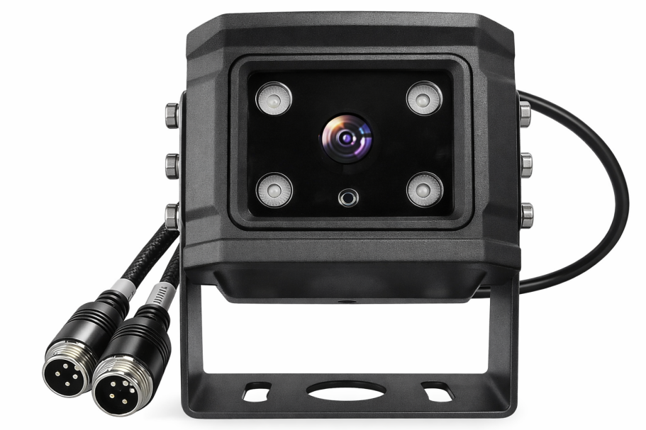
（M93Hv-2CH）

Product Introduction
M93H 4G camera is a comprehensive, lightweight, and easy-to-install wireless video application product. It features high integration, waterproof and shockproof design, simple installation, and meets the specific requirements of rapid deployment and remote dispatching. It is suitable for business scenarios such as construction site monitoring, vehicle surveillance, and theft prevention. The AI version also supports functions such as facial recognition, blind spot personnel detection, and driver fatigue warning.

Product Advantages
- Integrated design
- IP66 protection rating
- Equipped MIC-Online intercom
- Wide voltage supply
- Supports 4G , BD/GPS
- Supports multiple application platforms
- Supports video AI functions

Core parameters
project |  | Parameter Description
Video parameters | Built-in Input CMOS | 1080P 25/30fps
Video parameters | Infrared night vision | Automatic color-to-black switch at a distance of 10 meters.
Video parameters | Extended input video | External AHD 1080P input is available (optional).
Video parameters | Video output | AHD 720P/1080P output (optional)
Video parameters | Lens parameters | Default 2.8mm (View angle 105 °)
Audio parameters | Audio input | Built-in microphone (optional)
Audio parameters | Audio output | Built-in speaker
Storage method | TF card | 1 sheet, maximum 512GB
Positioning method | BeiDou/GPS | Supports mixed positioning
Network | 4G | Supports all network compatible 4G cards
Network | WIFI | No
Interface | Alarm input | 1-channel ADC input(optional)
Interface | Alarm output | 1-channel controllable 10V voltage output(optional)
Interface | RS232 | Supports one RS232 input (optional)
Power supply | Input voltage | 8-36V
Power supply | Output voltage | 10V (optional)
Power supply | Power Management | ACC power on/off, alarm input triggers power on/off
Power supply | Power connection method | Vehicle power supply and adapter, can be equipped with a dedicated UPS (plug and play, can work for 18 hours on a full charge).
Power supply | Power consumption | Standalone version: 1.9W during the day, 3.5W at night.
Intelligent algorithms | Dysfunction Driving Management System (DSM) | Facial recognition, closing eyes, yawning, making a phone call, smoking, looking left and right (optional)
Intelligent algorithms | Blind spot monitoring BSD | Personnel intrusion detection (optional)
Intelligent algorithms | Advanced Driver Assistance Systems (ADAS) | Lane departure warning, forward collision warning, and vehicle in front starting (optional)
Intelligent algorithms | License plate recognition | Supports license plate recognition, image capture, and uploading.(optional)
Physical Specifications | Size | 77.5 mm ( W ) * 61 mm ( H ) * 74 mm ( D )
Physical Specifications | Bracket height | 23.5mm
Physical Specifications | Weight | NW:0.42KG  (Fluctuation within 5%)
Work environment | Operating temperature | -20℃ to +70℃  (Good ventilation environment)
Work environment | Operating humidity | 10%–95% (non-condensing )
Other | Installation mode | Comes with stand
Other | Protection level | IP66

Note : The AI algorithm can only support one set at a time.

Interface Description
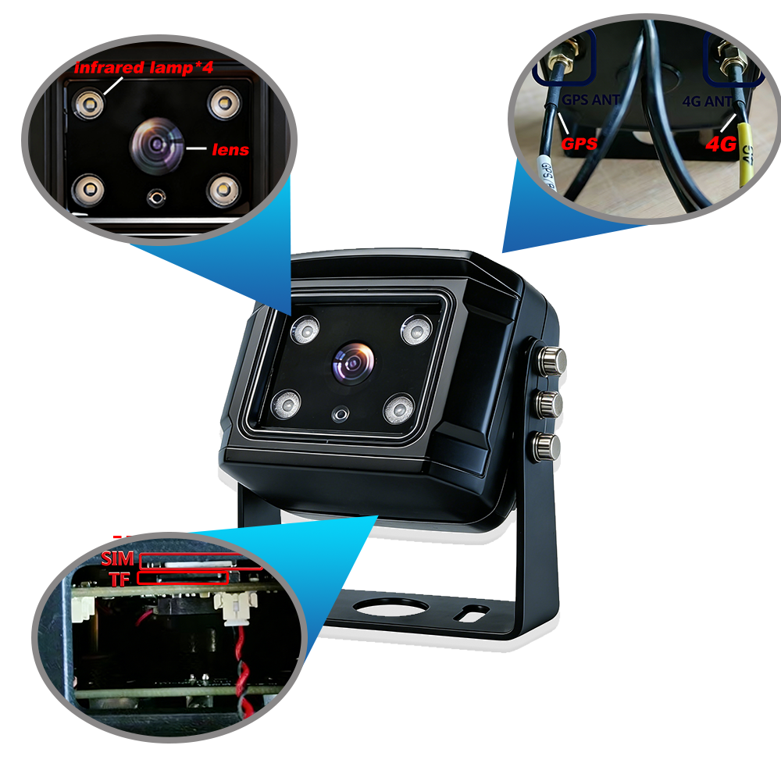
Dimensions
