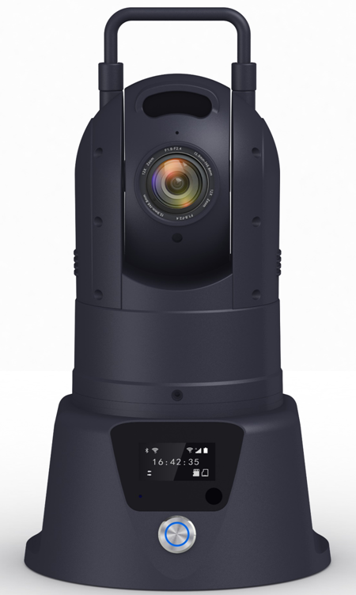
Product Introduction
The M9 2 Sv lightweight mini surveillance PTZ camera is a comprehensive, portable, and easy-to-install wireless video application product. It features high integration, a large-capacity lithium battery, waterproofing and shockproof design , and a miniature size, weighing only 2.5 kg , making it easily portable and meeting the special requirements of temporary rapid deployment and remote dispatching.

Product Advantages
- Lightweight design
- IP6 protection rating
- Voice intercom function
- Built-in high-capacity battery for long-lasting operation
- 360 ° omnidirectional PTZ control
- Supports 4G and WIFI
- Supports wired network ports
- Supports NARI encryption

Core parameters
project |  | Parameter Description
Video parameters | Video input | 1-channel IPC input
Video parameters | Optical zoom | Maximum 10 times
Video parameters | Night vision distance | 30 meters
Video parameters | Video encoding | H.264/H.265
Video parameters | Video pixels | The default maximum is 2K ( optional ) .
Video parameters | Support Agreement | GB2818 1. Private Protocol
Audio parameters | Audio input | Built-in microphone
Audio parameters | Audio encoding | G.711A, G.711U, PCM
Audio parameters | Audio output | Built-in speaker
Storage method | TF card ( standard version) | 1 sheet, maximum 1TB
Storage method | Dual SIM (NARI version) | Enabling the NARI encryption function allows for the addition of one more TF card .
Positioning method | BeiDou/GPS | Supports mixed positioning
network | 4G/5G ( Standard Version) | One 4G/5G SIM card (compatible with all networks )
network | Optional 4G card (NARI version) | NARI Encrypted Network: Supports one 4G SIM card compatible with all network types (optional)
network | WIFI | WIFI 6 (backward compatible with 5.8/2.4G )  Supports STA/AP modes
network | Wired network port | Route 1
Call the police | I/O | One input/one output (selectable, optional)
Gimbal | Horizontal range | 360° continuous rotation
Gimbal | Horizontal speed | 120°/s
Gimbal | Vertical range | -15°-90°
Gimbal | Vertical velocity | 60°/s
Gimbal | Preset point | 200
power supply | Built-in battery | 11.1V 10000mAh Lithium Battery Pack
power supply | Working hours | Daytime ≈ 20 hours/Nighttime ≈ 12 hours
power supply | Power Management | switch button
power supply | Charging mode | Desktop adapter (4A ) , M12 aviation connector (7 pins)
Physical Specifications | size | 150mm ( W ) * 250.8mm ( H ) * 99mm ( D )​​​
Physical Specifications | bracket height | Maximum height including bracket : 1700mm
Physical Specifications | weight | NW: 2.5KG, GW: 8KG (fluctuation within 5%)
Work environment | Operating temperature | -25℃ to +60℃ (in well-ventilated environments)
Work environment | Operating humidity | 10%–95% (non-condensing )
other | Installation mode | Comes with a built-in bracket/base magnetic attachment.
other | Protection level | IP6 6

Movement parameters
The movement parameters vary depending on the specific model of the equipment. If needed, please inform our company of your actual technical requirements for assistance.

Dimensions
