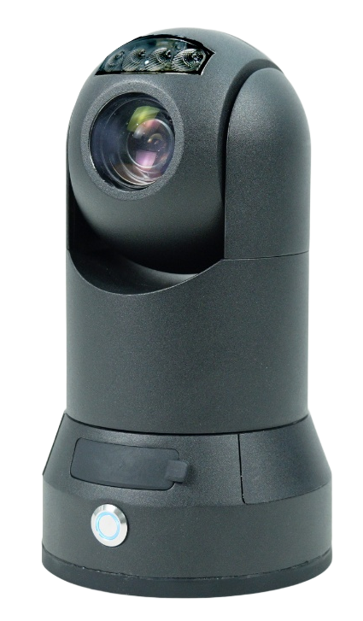
Product Introduction
The M91Sv lightweight MINI surveillance ball is a wireless video application integrated product with comprehensive functions, easy installation and use. It has the characteristics of high integration, large-capacity lithium battery pack, waterproof and shockproof, and MINI size. The bare weight is only 1.4KG , which can be carried around and meets the special requirements of temporary rapid surveillance and remote dispatching and command.
Product Advantages
- Lightweight design
- IP6-5 protection level
- Voice intercom function
- Built-in large-capacity battery, long-lasting work
- 360 ° PTZ control
- Support 4G , WIFI
- Support wired network port

Core parameters
project |  | Parameter Description
Video Parameters | IPC Input | 1
Video Parameters | Optical zoom | Maximum 10 times
Video Parameters | Night vision distance | 30m
Video Parameters | Video Encoding | H.264/H.265
Video Parameters | Video Pixels | Maximum 2K (optional)
Video Parameters | Support Agreement | GB28181. Private protocol
Audio parameters | Audio Input | built-in
Audio parameters | Audio Output | built-in
Storage | TF card | 1 , maximum 1T
Positioning method | BeiDou /GPS | Support, mixed positioning possible
network | 4G/5G | 1 piece
network | WIFI | 2.4G
network | Wired network port | 1 channel (optional)
Call the police | I/O | 1 channel (optional)
PTZ | Horizontal range | 360° continuous rotation
PTZ | Horizontal speed | 120°/s
PTZ | Vertical Range | -15° - 90°
PTZ | Vertical speed | 60°/s
PTZ | Preset Point | 200
power supply | Power | 5000mAh , 11.1V lithium battery pack
power supply | Working hours | during the day: 10 hours  Night time: 6 hours
power supply | Power Management | Switch button
power supply | Charging Mode | USB ( 2A ) / Power Bank
Physical specifications | size | 102.4mm ( W ) *188mm ( H ) *85mm ( D )
Physical specifications | Bracket height | Maximum height including bracket : 1.7m
Physical specifications | weight | NW: 1.4KG, GW: 2.7KG  (The remaining floating rate is 5%)
Work Environment | Operating temperature | -25℃～+60℃  (Good ventilation environment)
Work Environment | Operating humidity | 10%～95% (no condensation )
other | Installation Mode | Comes with bracket/ chassis magnet adsorption
other | Protection level | IP65

Movement parameters
Movement parameters are configured according to the specific model of the equipment. If necessary, please inform our company of your actual technical requirements for assistance.

Dimensions
