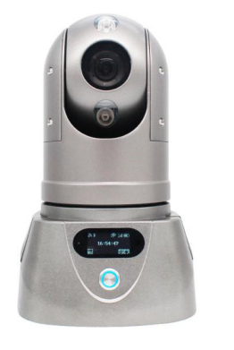

Product introduction
4G HD IR PTZ Camera is a professional HD IR PTZ camera integrated with record, HD video wireless transmit, audio ,talk and remote control. It adopts high speed processor hardware and embedded Linux system. The state of the art HD camera use the latest IT technologies, such as H.265 code, wireless transmitting technologies, remotely control etc.

Product advantages
- The in-vehicle interface can operate reliably and stably in complex environments
- Video encoding H.265, H.264 optional
- Support 4G /5G , GPS function module
- Support one SD card
- Abundant peripheral interfaces
- Support external UPS battery life
- High scalability

Core parameters
project |  | Parameter Description
Video Parameters | IPC Input | 1st Road
Video Parameters | CVBS output | 1 (built-in)
Video Parameters | Video Encoding | H.264/H.265
Video Parameters | Video resolution | Maximum 4K (optional)
Video Parameters | Support Agreement | GB28181 , private protocol
Audio parameters | Audio Input | Bluetooth hand tag/built-in MIC
Audio parameters | Audio Output | Bluetooth Hand Tag
Audio parameters | Audio Coding | G.711A
storage | SD Card | 2 sheets, maximum 512G*2
Positioning method | BeiDou/GPS | Support, mixed positioning possible
network | 4G | 1/2 SIM cards (optional)
network | WIFI | 2.4G
network | RJ45 | 1st Road
Call the police | I / O | 1 channel (optional)
PTZ | Horizontal range | 360° rotation
PTZ | Horizontal speed | 120°/s
PTZ | Vertical Range | -15° - 90°
PTZ | Vertical speed | 60°/s
PTZ | Preset Point | 200
power supply | Power | Daytime work ≈ 15 hours / Nighttime work ≈ 10 hours  Can be powered by external power supply
power supply | Power Management | Switch button
Physical specifications | size | 170mm(W)*277mm(H)*170mm(D)
Physical specifications | Bracket height | 1330mm
Physical specifications | weight | NW: 4.3kg GW : 11.3kg  ( with a fluctuation of 5% )
Work Environment | Operating temperature | -25℃～+60℃  (Ambient temperature under well-ventilated conditions)
Work Environment | Operating humidity | 10%～95% (no condensation)
other | Installation Mode | Comes with bracket/ chassis magnet adsorption
other | Protection level | IP66

Product Size


