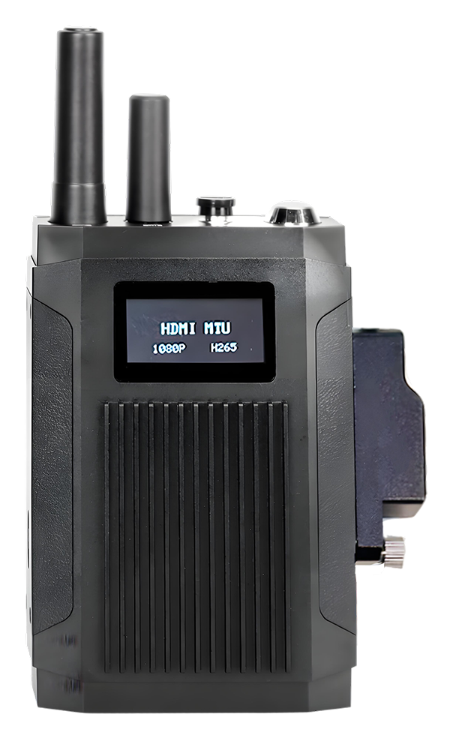

Product Introduction
The M71Hv portable video transmission system is a highly portable and extensible product developed for drone monitoring, capturing, command, and HDMI-based ultra-high-definition video transmission. The product features an integrated industrial design, incorporating hardware audio-video encoding, 5G/4G networks, GPS & BeiDou positioning, data storage, and lithium battery modules. It can connect to drones, robots, and DV cameras via an HDMI interface, enabling the management end to remotely access ultra-clear real-time video from the operation site.

Product Advantages
- IP65 protection level, suitable for various complex environments
- Video coding H.265, H.264 optional
- Support 5G, 4G, WIFI, GPS function modules
- Support a MicroSD (TF) card storage
- Built-in lithium battery, continuous work for 8 hours
- Support two-way intercom and cluster intercom;
- Comes with an anti-glare status display
- Comes with USB, HDMI and other interfaces
- High scalability

Core Parameters
project |  | Parameter Description
Audio and video input | AHD Input | 1
Audio and video input | HDMI input | 1
Audio and video input | Audio Input | 1 (Bluetooth)
Audio and video input | Wired MIC | support
Audio Output | Voice Output | 1 (Bluetooth)
Audio Output | Wired headphones | support
Audio and video parameter encoding | Video Encoding | H.264/H.265
Audio and video parameter encoding | Video resolution | 1080P/720P
Audio and video parameter encoding | Audio Coding | G711A , G711U , AAC
Storage Space | TF card | 1 sheet, maximum 1T
Wireless network | 5G/4G Wireless | 2 SIM cards​  ( With built-in 5G or 4G card access port , supports 1.4G private network)
Wireless network | WIFI | WiFi Client connection / WiFi AP hotspot
Positioning method | BeiDou /GPS | Support, mixed positioning possible
power supply | Battery capacity | 7.4v 6000mAh lithium battery pack
power supply | Power Management | Key switch , automatic screen saver
power supply | Type-C charging | Support (current >2A )
power supply | Magnetic charging | support
Screen | OLED screen | 1.54 inches
Screen | show | Positioning, network, power, time
button | SOS button | 1
interface | External AHD | 1 ( 4- core M6 aviation connector )
interface | TYPE-C | Charging / network port
interface | Mini HDMI | 1
Physical specifications | size | 149mm ( L ) *98.1mm ( W ) *42.6mm ( H )  (without antenna, back clip)
Physical specifications | weight | NW 0.74 kg ( up or down 5%)
Work Environment | Operating temperature | -20 ～ +6 0 ℃
Work Environment | Operating humidity | 8% ~ 90% (no condensation)
other | Remote Control | PC , APP​
other | Support Agreement | GB28181 , private protocol

Appearance
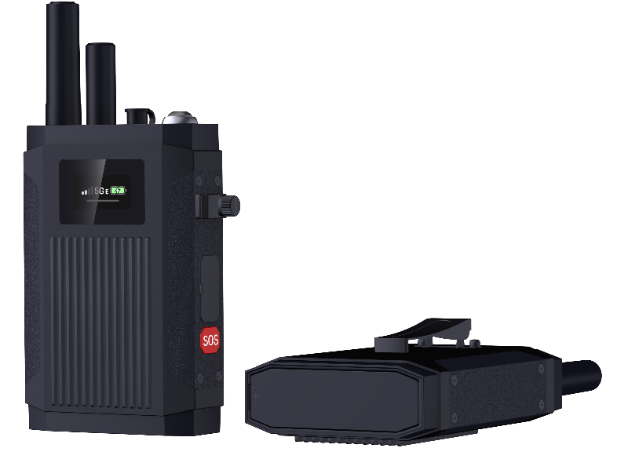

Buttons and Interfaces
Top Structure
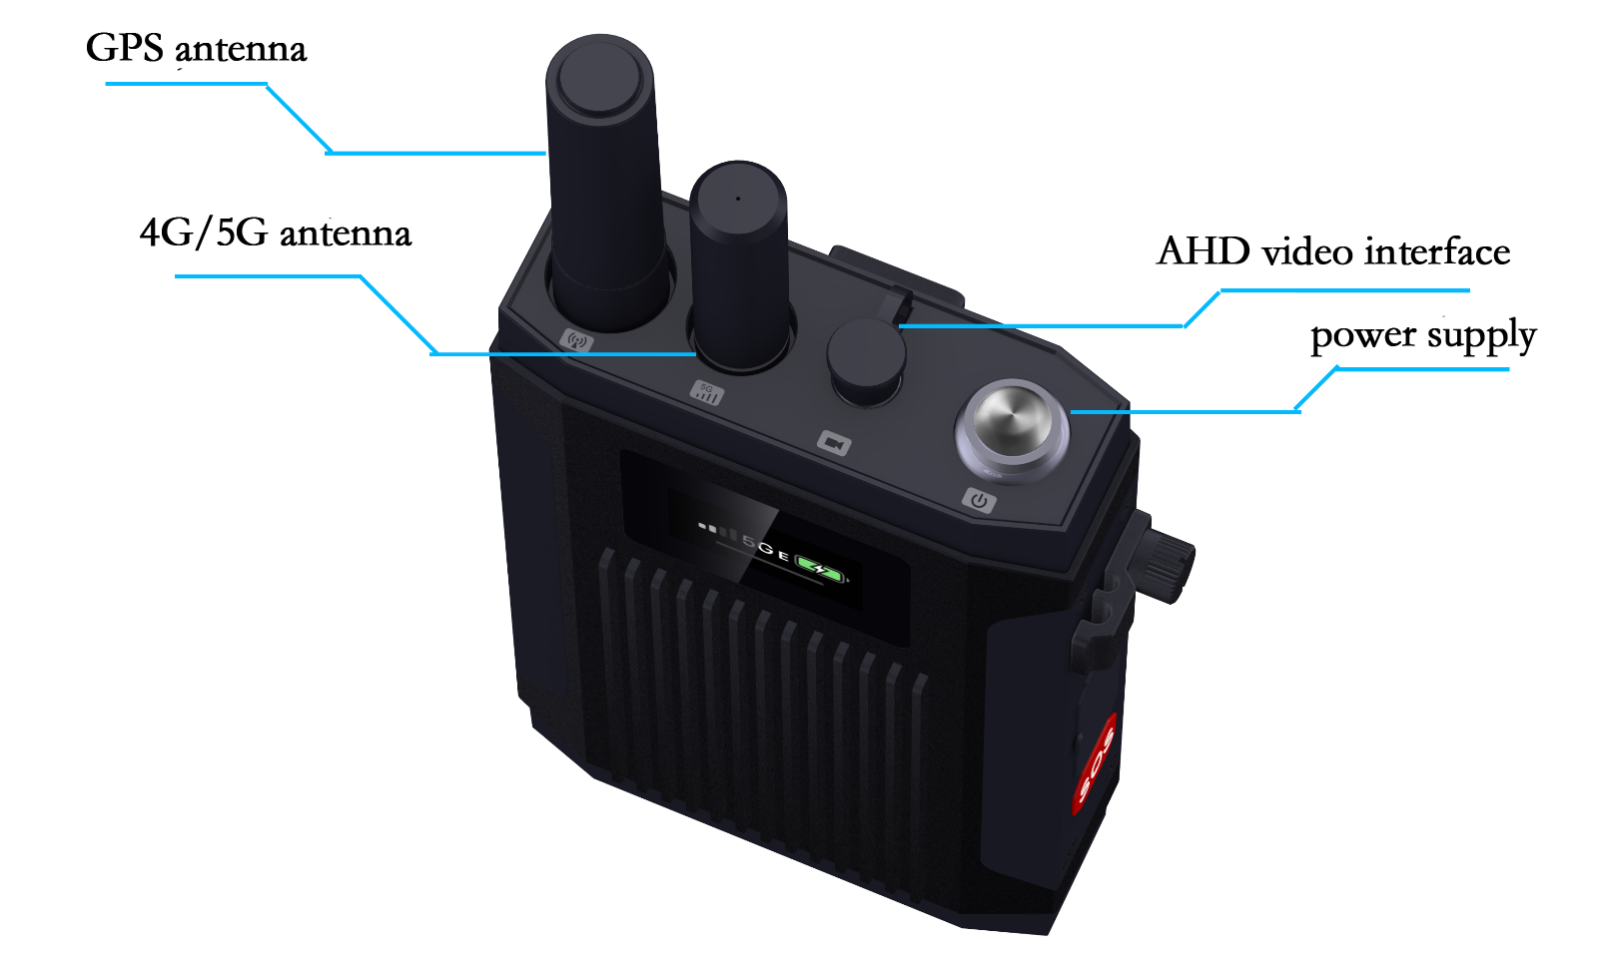

Side Structure
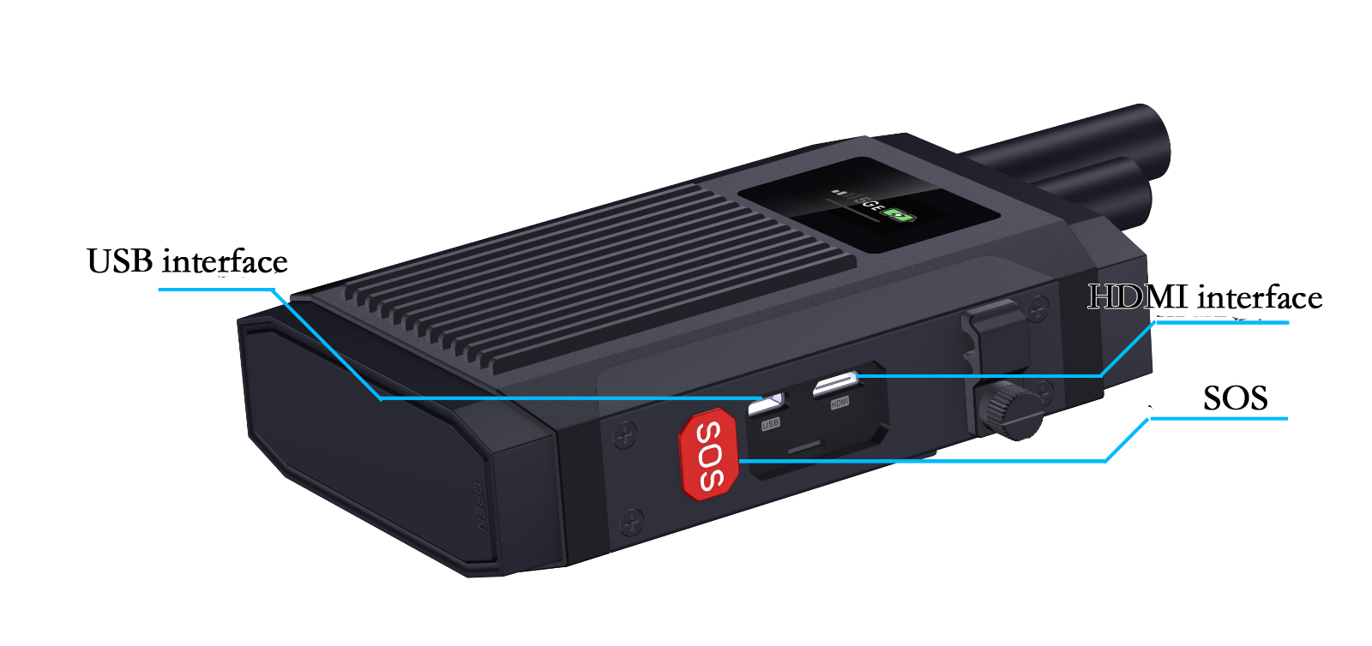
Bottom Structure
