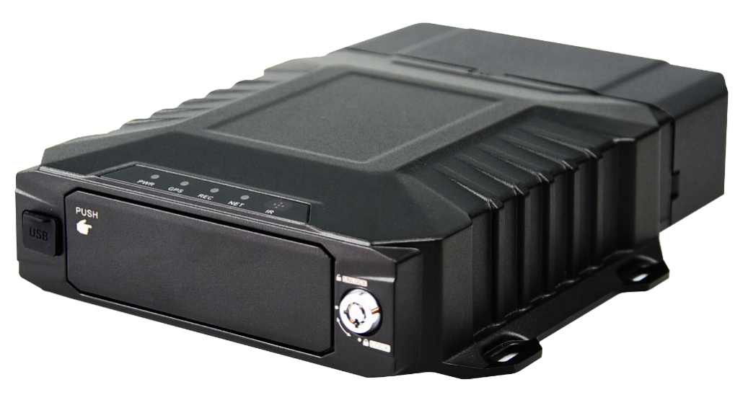

Product introduction
M51/52Hv is designed for vehicle video monitoring, remote video monitoring development of a high-performance, highly expandable product, featuring a self-ejecting hard drive structure and high-speed processor NT98323 and embedded operating system, integration of IT cutting-edge field H.264/H.265 video compression or decompression, 4G network, GPS/BD positioning technology. It has the characteristics of strong earthquake resistance, simple appearance, flexible and convenient installation, comprehensive function and high reliability.

Product Advantage
- The interface can operate reliably and stably in complex environments
- Video encoding H.265, H.264 is optional
- Support 4G WIFI and GPS functional modules
- Supports a 2.5-inch optional SSD/HDD hard disk
- Supports one SD card
- Rich peripheral interfaces
- Support external UPS battery life
- High scalability

Core parameters
Project |  | Parameter Description
Audio and video input | AHD Video Input | M51Hv external 4 * 1080P  M52Hv external 8*1080P
Audio and video input | Video Standards | 30FPS (4 channels) / 15FPS (8 channels)
Audio and video input | Audio Input | 5
Audio and video output | CVBS output | 1
Audio and video output | VGA output | 1(optional)
Audio and video output | Audio Output | 1
Audio and video parameter encoding | Video Encoding | H.264/H.265
Audio and video parameter encoding | Video resolution | 1080P/720P/D1
Audio and video parameter encoding | Audio Coding | G.711A
Storage Space | Harddisk | SSD/HDD, maximum 8T
Storage Space | SD Card | 1 card, maximum 1T
Wireless network | 4G Wireless | 1 SIM card
Wireless network | WIFI | 2.4/5.8G ( optional)
Positioning method | BeiDou /GPS | Support, mixed positioning possible
Interface | RS232 | 1 group
Interface | RS485 | 1 group
Interface | SENSOR | 4
Interface | SENSOR OUT | 2
Interface | ADC | 2
Interface | USB | 1
Interface | NET | 1
Interface | MIC | 1
Physical specifications | Size | 176.9mm ( L ) *186.8mm ( W ) *54mm ( H )  (without cable shroud)
Physical specifications | Weight | NW：1.4kg，GW:2kg​  (fluctuating 5% up and down)
Work Environment | Operating temperature | -20 ～ +70 ℃
Work Environment | Operating humidity | 8% ~ 90% (no condensation)
Other | Operation Mode | Remote control, APP , WEB
Other | G SENSOR | Support

Size
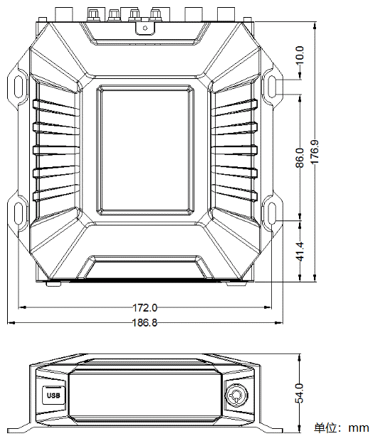
Panel& interface
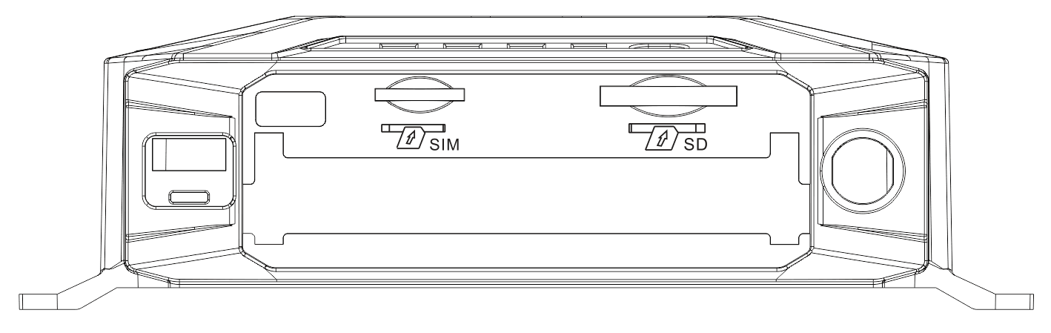
Front panel
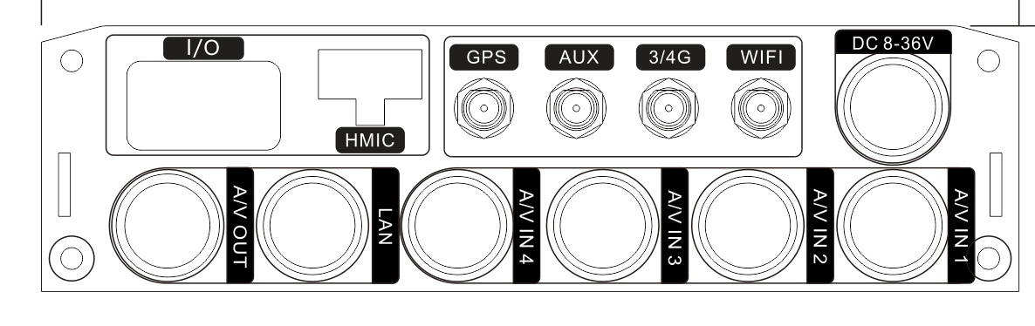
Rear panel

