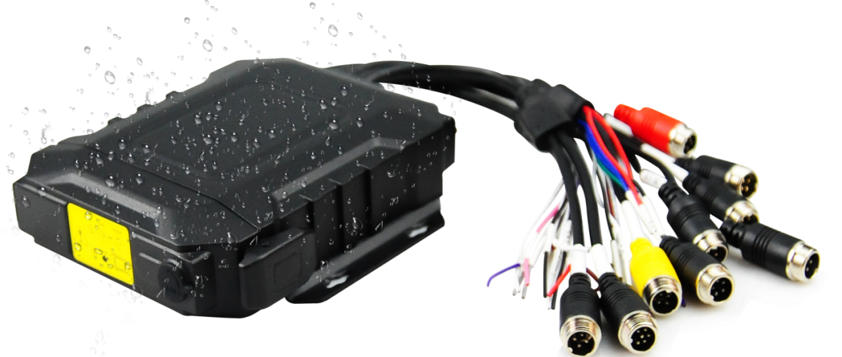

Product introduction
M32Hv series is a dedicated vehicle-mounted audio and video surveillance product that uses a high-speed processor. It adopts a waterproof and dustproof structural design and an embedded operating system, integrating IT cutting-edge technologies such as H.264/H.265 video compression / decompression, 4G network, GPS/BD positioning, etc. It has the characteristics of strong earthquake resistance, simple appearance, flexible and convenient installation, comprehensive functions, and high reliability.
Product Advantage
- The interface can operate reliably and stably in complex environments
- Video encoding H.265, H.264 is optional
- Support 4G 、WIFI and GPS functional modules
- Supports a 2.5-inch optional SSD/HDD hard disk
- Support two SD cards
- Rich peripheral interfaces
- Support external UPS battery life
- Waterproof dust-proof

Core parameters
Project |  | Parameter Description
Audio and video input | AHD Video Input | External 4 * 1080P
Audio and video input | Video Standards | 30fps
Audio and video input | Audio Input | 4+1
Audio and video output | CVBS output | 1
Audio and video output | VGA output | 1 (optional)
Audio and video output | Audio Output | 1
Audio and video parameter encoding | Video Encoding | H.264/H.265
Audio and video parameter encoding | Video resolution | 1080P/720P/D1
Audio and video parameter encoding | Audio Coding | G.711A
Storage Space | Solid State Drive | 1, maximum 8TB
Storage Space | SD Card | 2 sheets , maximum 1T*2
Wireless network | 4G Wireless | 1 SIM card
Wireless network | WIFI | 2.4/5.8G ( optional)
Positioning method | BeiDou /GPS | Support, mixed positioning possible
Interface | RS232 | 1 group
Interface | RS485 | 1 group (enhanced version)
Interface | SENSOR | 2/4 (Enhanced Edition)
Interface | SENSOR OUT | 2 (Enhanced version)
Interface | ADC | 2 (Enhanced version)
Interface | USB | 1 ( Enhanced version)
Interface | NET | 1 (Enhanced version)
Interface | MIC | 1
Physical specifications | Size | 154mm ( L ) *148mm ( W ) *39mm ( H )  (excluding tail wire)
Physical specifications | Weight | NW：1.10 kg，GW：1.40 kg  (fluctuating 5% up and down)
Work Environment | Operating temperature | -20°C to +70°C
Work Environment | Protection level | 10% ~ 95% (no condensation)
Work Environment | Protection Rating | IP66
Other | Operation Mode | Remote control, APP , WEB
Other | G SENSOR | support

size
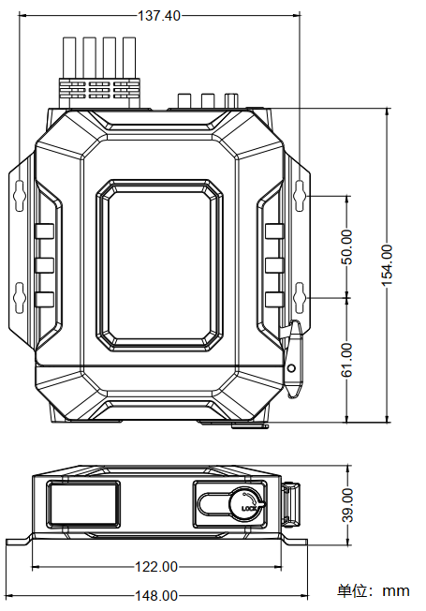

Panel& interface
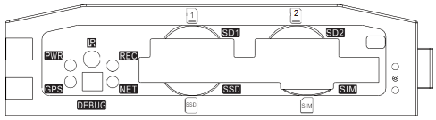
Front panel
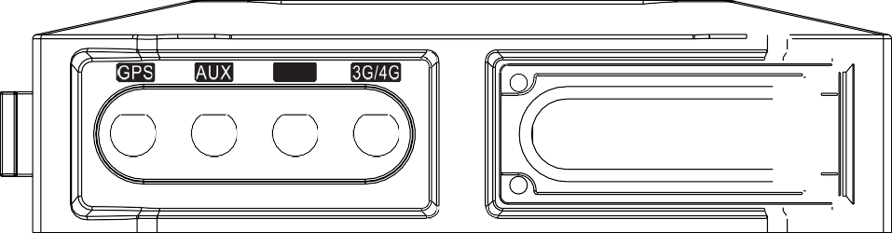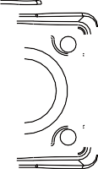
WIFI
Rear panel

