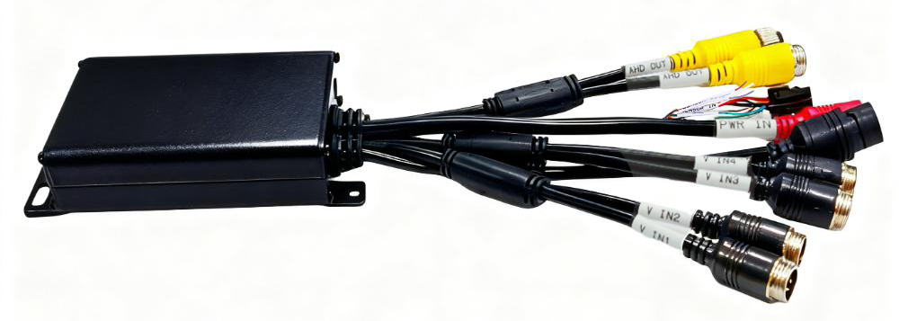

Note: The appearance of the device may vary slightly depending on the version.
Product Introduction
The M25Hv series is designed for in-vehicle video surveillance, intelligent image recognition, and highly expandable products. It utilizes the high-speed NT98321 processor and an embedded operating system, integrating cutting-edge IT technologies such as H.264/H.265 video compression / decompression. Its multi-functionality allows for diverse product development, such as: a 4- channel video splitter, a 4- channel BSD intelligent recognition alarm, and a DMS ( Driver Fatigue Assist System).

Product Advantages
- Supports up to 4 AHD video inputs
- Video encoding options : H.265 or H.264
- Supports AHD 1080P output.
- Supports one TF card
- Abundant peripheral interfaces
- High scalability

Core parameters
project |  | Parameter Description
AI Functions | ADAS, DSM, BSD | Full-featured AI
Video input | AHD input | External 4 * 1080P
Audio and video output | AHD output | Route 1 ( 1080P )
Audio and video output | Voice output | 1 ( four-core male connector，yellow )
Video parameter encoding | Video encoding | H.264/H.265
Video parameter encoding | Video resolution | 1080P/720P/D1
Storage space | TF card | 1, maximum 1TB
Interface | RJ45 | 1 ( 100MB )
Interface | RS232 | 1( GPS module )
Interface | SENSOR OUT | 1
Interface | M12 4-core aviation female connector (V) | 4  ​( 4- channel AI video input )
Interface | M12 4-core aviation male connector (V) | 1( AHD video output )
Interface | M12 4-core aircraft carrier bow ( A ) | 1​  ( For external speaker output )
Physical Specifications | Size | 1 30 mm (L) * 71.2 mm (T) * 27.8 mm (H)
Physical Specifications | Weight | GW：0.3kg; NW：0.34kg
Work environment | Operating temperature | -20 to +70℃
Work environment | Operating humidity | 8%~90% (non-condensing)
other | Operating mode | Mobile App, Web

Dimensions

