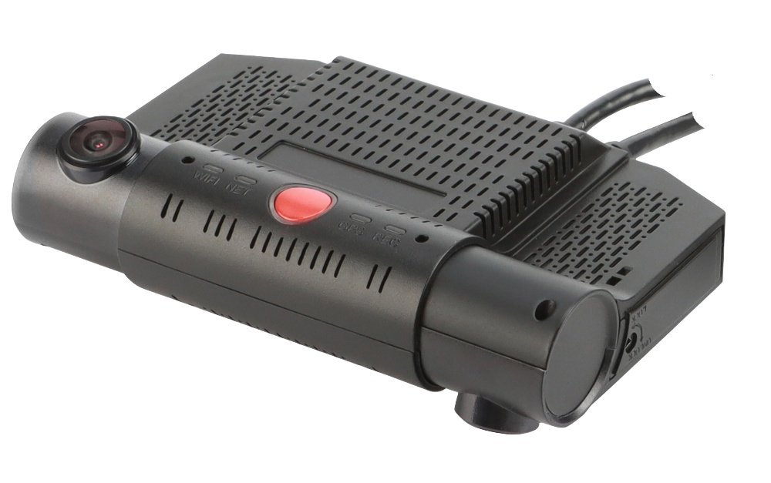

Product introduction
M20Ev series is an integrated design with front and rear dual cameras, 4G, GPS and WIFI. While the rear camera can record the car, the front camera can also record the road information, which has obvious advantages in convenience and security. M20Ev series support H.265 video decoding technology, GPS/BD positioning technology and other mainstream video/network technology.

Product Advantage
- The on-board interface can operate reliably and stably in complex environments
- Video encoding H.265, H.264 is optional
- Support 4G, WIFI, GPS function module
- Supports 2 TF cards. Comes with dual cameras
- Adhesive backing allows for quick installation

Core parameter
Project |  | Parameter Description
Audio and video input | Video Input | Built-in: 2*1080P  External: 2*1080P AHD
Audio and video input | Built-in camera perspective | Outside view：D:130°H:105°V:53°  Inside view：D:157°H:127°V:65°
Audio and video input | Video Standards | 25FPS
Audio and video input | Audio Input | 1 built-in channel
Audio and video output | CVBS output | Resolution D1, 2-split view  (2 external cameras with 4 partitions)
Audio and video output | Audio Output | built-in
Audio and video parameter encoding | Video Encoding | H.265/H.264
Audio and video parameter encoding | Video resolution | 1080P/720P/D1
Audio and video parameter encoding | Audio Coding | G.711A
Storage Space | TF card | 2, maximum 1TB*2
Wireless network | 4G Wireless | 1 SIM card
Wireless network | WIFI | 2.4G
Positioning method | BeiDou/GPS | Support, mixed positioning possible
interface | RS232 | 1 group
interface | SENSOR | 1
interface | SENSOR OUT | 1
interface | ADC | 1
Physical specifications | Size | 126 mm (L) * 81.5 mm (W) * 41 mm (H)
Physical specifications | Weight | NW: 0.3 kg GW: 0.65 kg  （with a fluctuation of 5% )
Work Environment | Operating temperature | -20～+70℃
Work Environment | Operating humidity | 8%～90% (no condensation)
Other | SOS button | Support
Other | Collision Sensor | Support
Other | GSensor | Support
Other | Linkage alarm | Acceleration, rollover, collision trigger

Size

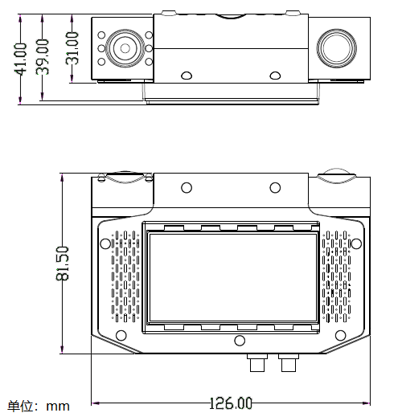
Body mechanism
Front panel
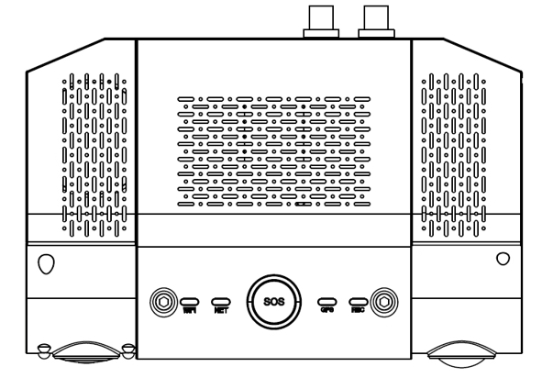
Rear panel
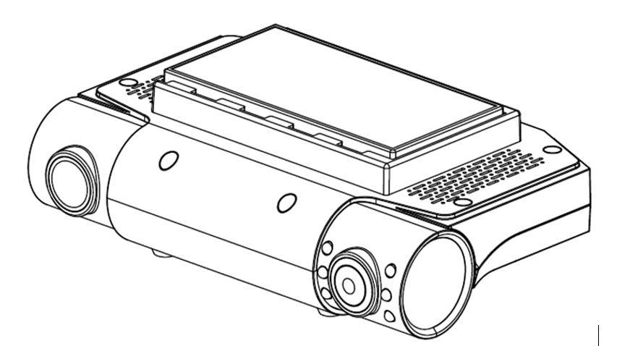
construction profile
