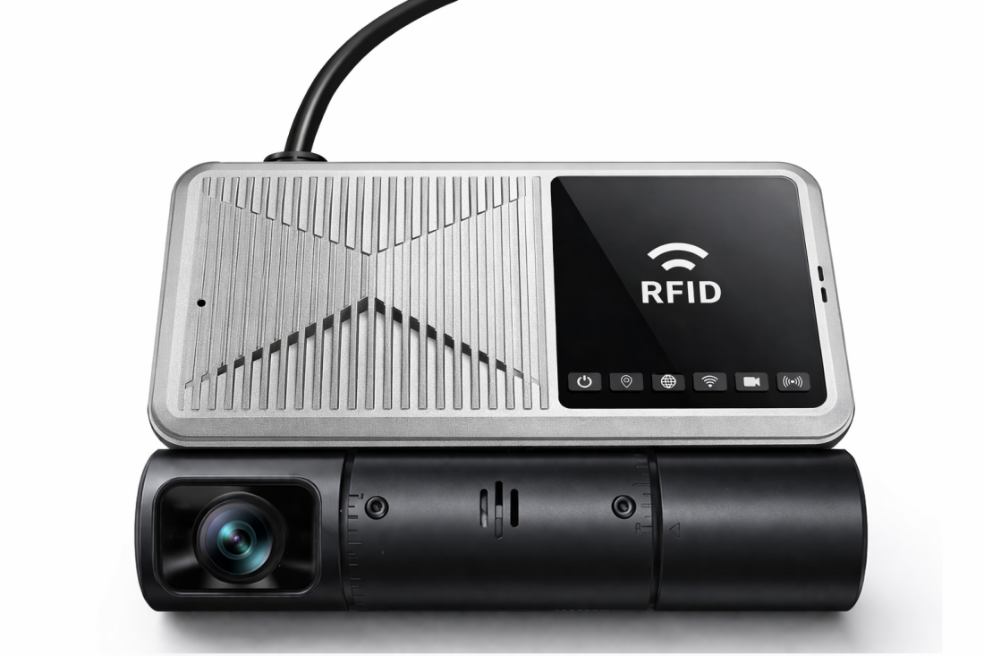
( RFID version )
Product Introduction
The M19Ev series features an integrated design, incorporating front and rear dual cameras, 4G, Wi-Fi, and GPS. While the rear camera records the vehicle's interior environment, the front camera simultaneously records road conditions, offering significant advantages in convenience and safety. The M19Ev series supports mainstream technologies such as H.265 video encoding and GPS/BD hybrid positioning. Optional features include rapid detection and collision detection, making it suitable for onboard or remote monitoring environments in freight vehicles, passenger buses, construction vehicles, sanitation vehicles.

Product Advantages
- Specialized vehicle interface ensures reliable and stable operation in complex environments.
- Video encoding options: H.265 or H.264
- Built-in 4G, WIFI, and GPS modules
- Supports two Micro-SD (TF) cards .
- Built-in front and rear dual cameras
- It has an adhesive side and supports quick installation.
- RFID support (optional)

Core parameters
Project |  | Parameter Description
Audio and video input | Video input | Built-in 2* CMOS 1080P cameras ( front and rear dual view )
Audio and video input | Forward focal length | 3.0MM
Audio and video input | Forward view | HFOV=111° VFOV=59° DFOV=133°
Audio and video input | Intraocular focal length | 2.1MM
Audio and video input | Inner vision | HFOV=130° VFOV=73° DFOV=160°
Audio and video input | Audio input | Built-in 1 microphone
Audio and video output | Audio output | Built-in 1-channel speaker
Audio and video parameter encoding | Video encoding | H.265/ H.264
Audio and video parameter encoding | Video resolution | 1080P/720P/D1
Audio and video parameter encoding | Audio encoding | G.711A
Storage space | TF card | 2 cards, maximum 512GB *2
Wireless network | 4G wireless | 1 SIM card
Wireless network | WIFI | 2.4G
Positioning method | BeiDou/GPS | Supports mixed positioning
interface | RS232 | Group 1
interface | Sensor | 1  High-level alarm: 3.3~36V / Low-level alarm: 0~3.3V
interface | Sensor out | 1
interface | ADC | 1 (Analog input, optional)
Physical Specifications | Size | 123.6mm (L)*80.5mm (W)*47.7mm (H)
Physical Specifications | Weight | NW: 225g  GW : 400g (M19Ev standard version)
Work environment | Operating temperature | -20 to +70℃
Work environment | Operating humidity | 8%~90% (non-condensing)
other | RFID | Built-in card swiping function (ISO15693 protocol , optional )
other | Collision sensing | Post-parking collision detection
other | Gravity sensor | Built-in GSensor
other | Linked alarm | Alarms triggered by acceleration, rollover, and collision.

Product Dimensions
