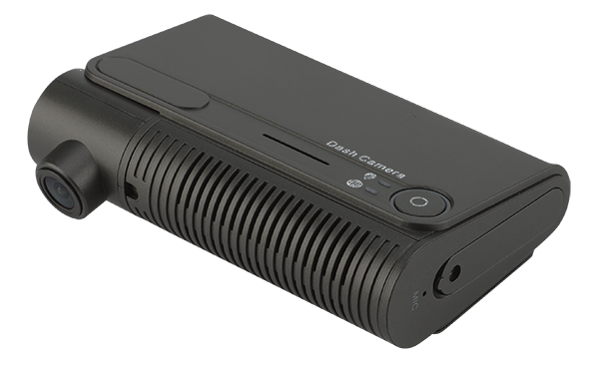

Product Introduction
M18Ev is a car mounted device that adopts an integrated structure. The device comes with one front facing camera and integrates 4G, WIFI, GPS, GSENSOR and other modules internally. Equipped with a 1080P high-definition camera, it is both convenient and secure.

Product advantages
- Video encoding H.265 and H.264 are optional
- Built in 4G, WIFI, GPS function modules
- Supports 2 TF card
- Comes with 1 built-in camera
- Equipped with adhesive surface, supporting quick installation

Core parameters
Project |  | Parameter Description
Audio and video input | Video Input | Built-in: 1*1080P  External: 3*1080P AHD/1*1080P IPC (optional)
Audio and video input | Built-in camera perspective | D:130°H:105°V:53°
Audio and video input | Video Standards | 30FPS
Audio and video input | Audio Input | built-in
Audio and video output | CVBS output | Support
Audio and video output | Audio Output | Built-in
Audio and video parameter encoding | Video Encoding | H.264/H.265
Audio and video parameter encoding | Video resolution | 1080P/720P/D1
Audio and video parameter encoding | Audio Coding | G.711A
Storage Space | TF card | 2, maximum 1T*2
Wireless network | 4G Wireless | 1 SIM card
Wireless network | WIFI | 2.4G
Positioning method | BeiDou/GPS | Support, mixed positioning possible
interface | RS232 | 1 group
interface | SENSOR | 1 (optional)
interface | SENSOR OUT | 1 (optional)
interface | ADC | 1 (optional)
Physical specifications | Size | 110mm (L)*70.5mm (W)*35.6mm (H)
Physical specifications | Power cord | Length 2m, diameter 5.1mm
Physical specifications | Video cable | 3 (optional), 3m long, 3.5mm in diameter
Physical specifications | Weight | NW: 0.22kg，GW: 0.62kg  (with a fluctuation of 5%)
Work Environment | Operating temperature | -20～+70℃
Work Environment | Operating humidity | 8%～90% (no condensation)
Other | Power Management | Switch button
Other | G SENSOR | Support
Other | Linkage alarm | Acceleration, rollover, collision trigger
Other | Power consumption | ≈4W

Fuselage mechanism
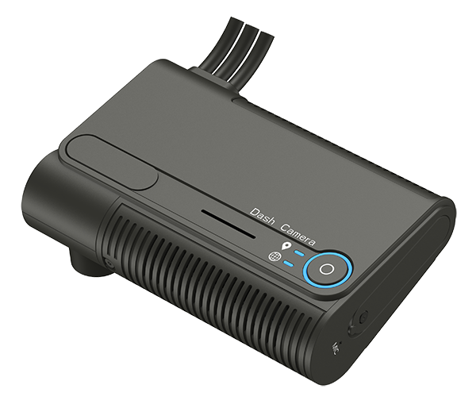
front panel
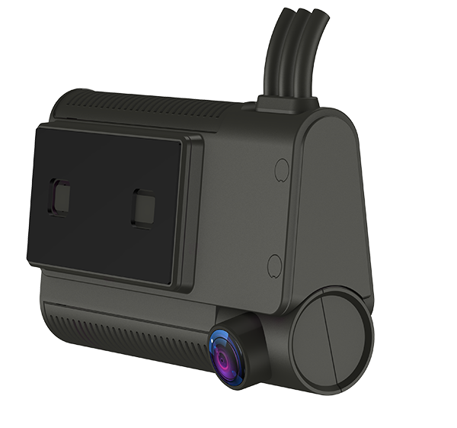
Rear panel
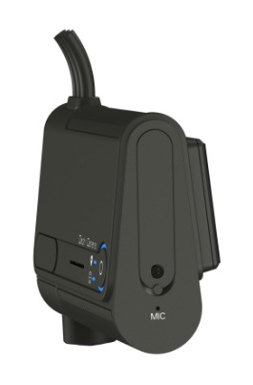
Side structure

