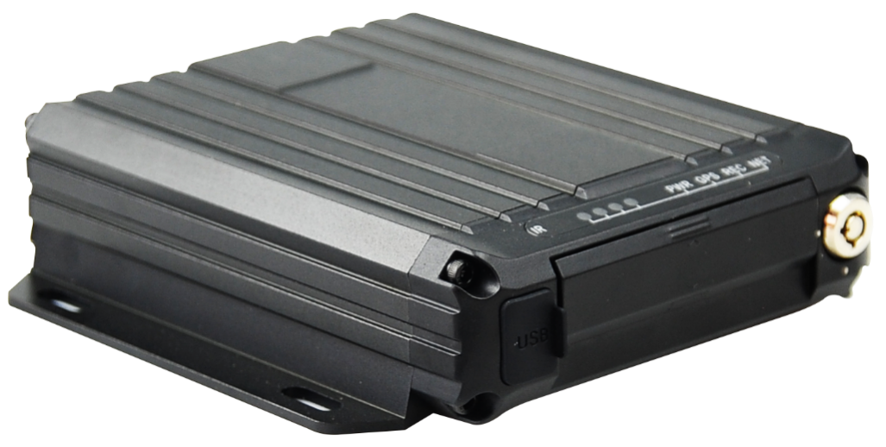

Product Parameters
The M16Hv series uses a mini body, which can be easily installed and used in small spaces. Support dual SD card, effectively improve the storage space. The products are compatible with mainstream H.265 video decoding technology, 4G network technology, GPS/BD positioning technology, WIFI technology, etc., which are suitable for all kinds of road patrol vehicles, mixing trucks, logistics vehicles, dump trucks and other industrial vehicles.

Product advantages
- The on-board interface can operate reliably and stably in complex environments
- Video encoding H.265, H.264 is optional
- Support 4G, GPS, WIFI function modules
- Rich peripheral interfaces
- Support UI human-computer interface
- Support dual SD card storage
- Support remote system maintenance

Core parameters
project |  | Parameter Description
Audio and video input | AHD Video Input | External 4 * 1080P
Audio and video input | Video Standards | 30FPS
Audio and video input | Audio Input | 3
Audio and video output | CVBS output | 1
Audio and video output | VGA output | 1(optional)
Audio and video output | Audio Output | 1
Audio and video parameter encoding | Video Encoding | H.264/H.265
Audio and video parameter encoding | Video resolution | 1080P/720P/D1
Audio and video parameter encoding | Audio Coding | G.711A
Storage Space | SD Card | 2, maximum 1TB*2
Wireless network | 4G Wireless | 1 SIM card​
Wireless network | WIFI | 2.4 / 5.8G ( optional)
Positioning method | BeiDou /GPS | Support, mixed positioning possible
Interface | RS232 | 1 group
Interface | RS485 | 1 group
Interface | SENSOR | 4
Interface | SENSOR OUT | 1
Interface | ADC | 2
Interface | USB | 1
Interface | NET | 1
Physical specifications | Size | 135.5mm ( L ) *137.7mm ( W ) *36.5mm ( H )
Physical specifications | Weight | NW：0.5kg，GW：0.75kg  ( with a fluctuation of 5% )
Work Environment | Operating temperature | -20 ～ +70 ℃
Work Environment | Operating humidity | 8% ~ 90% (no condensation)
Other | Operation Mode | Remote control, APP , WEB
Other | G SENSOR | Support

Size
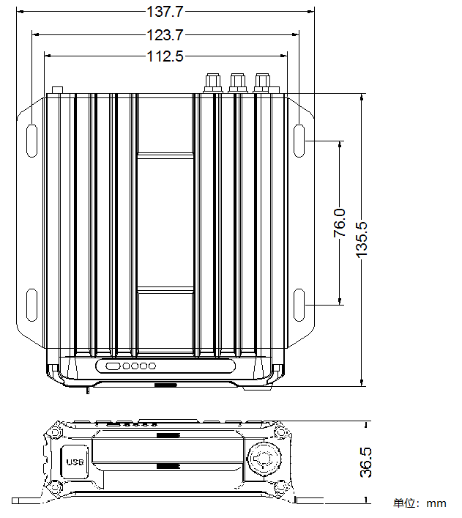

Panel&interface
Front panel
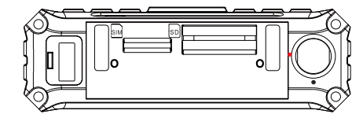
Rear panel
