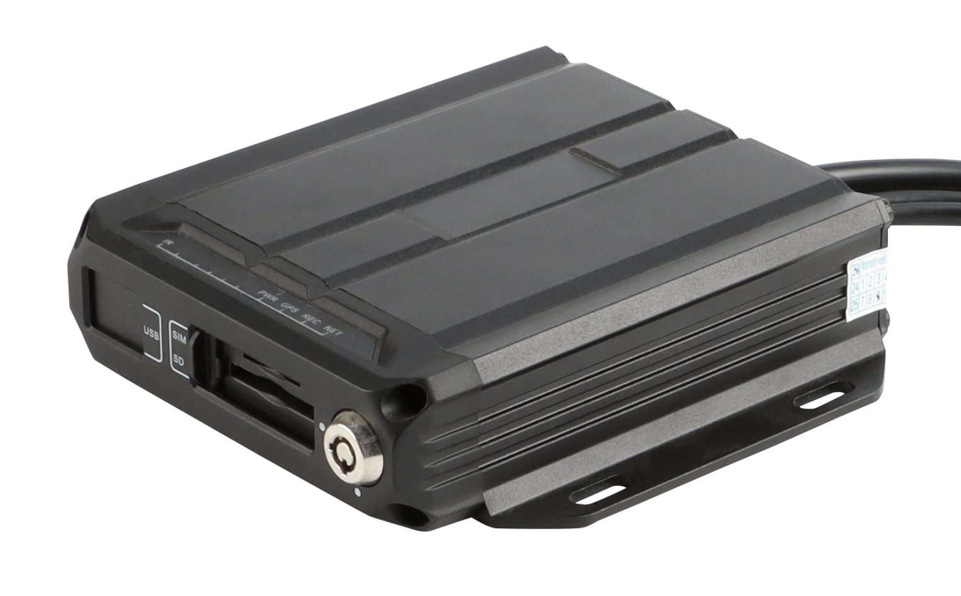

Product introduction
M15Hv is a high-performance, high- expansion product specially developed for in-vehicle video surveillance and remote video surveillance. etc. technology. M15Hv has a compact structure, elegant appearance, and easy installation and use. It is a basic product for lightweight applications. It is suitable for public safety, long-distance passenger transportation, road inspection and other automotive mobile monitoring fields.
Product advantages
- The in-vehicle interface can operate reliably and stably in complex environments
- Video encoding H.265, H.264 optional
- Support 4G , GPS function module
- Support one SD card
- Abundant peripheral interfaces
- Support external UPS battery life
- High scalability

Core parameters
Project |  | Parameter Description
Audio and video input | AHD video input | External 4 * 1080P
Audio and video input | Video standards | 30FPS
Audio and video input | Audio Input | 2
Audio and video output | CVBS output | 1
Audio and video output | VGA output | 1 (optional)
Audio and video output | Audio output | 1
Audio and video parameter encoding | Video encoding | H.264/H.265
Audio and video parameter encoding | Video resolution | 1080P/720P/D1
Audio and video parameter encoding | Audio coding | G.711A
Storage Space | SD card | 1 , maximum 1T
Wireless network | 4G wireless | 1 SIM card
Positioning method | BeiDou /GPS | Support, mixed positioning possible
Interface | USB | 1​
Interface | RS232 | 1 group
Interface | RS485 | 1 group(optional)
Interface | SENSOR | 4
Interface | SENSOR OUT | 1
Interface | NET | 1 (optional)
Physical specifications | Size | 102.8mm ( L ) *120mm ( W ) *32.23mm ( H )  (excluding tail wire)
Physical specifications | Weight | NW：0.6kg，GW：0.8kg  ( with a fluctuation of 5% )
Work Environment | Operating temperature | -20 ～ +70 ℃
Work Environment | Operating humidity | 8% ~ 90% (no condensation)
Other | Operation Mode | Remote control, mobile phone APP , WEB

Product Size
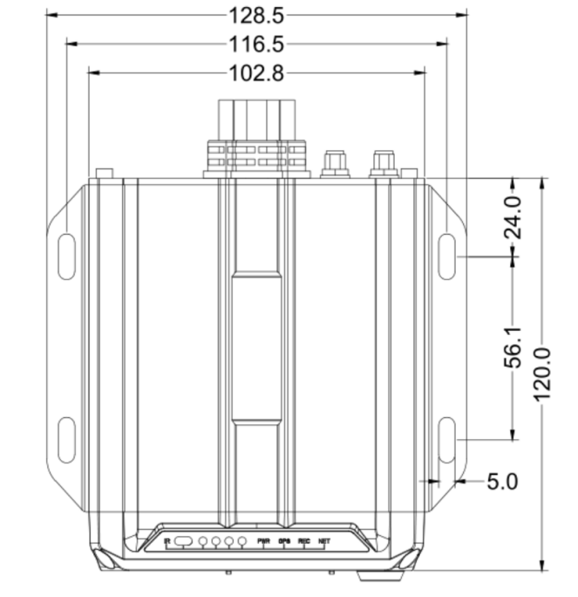
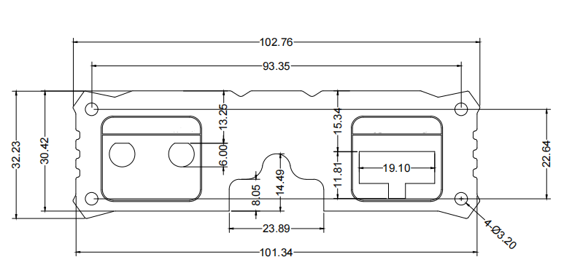
Unit: mm
Panel interface
front panel
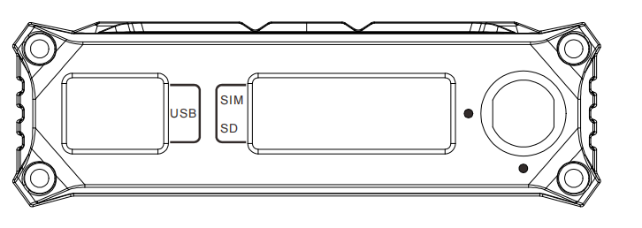
rear panel
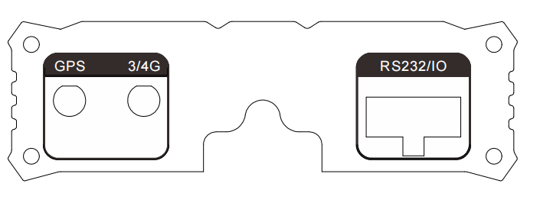
tail line definition
