PTZ--Relay connection
As following:
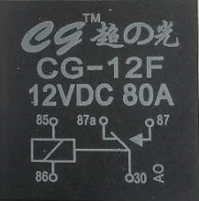

Connection
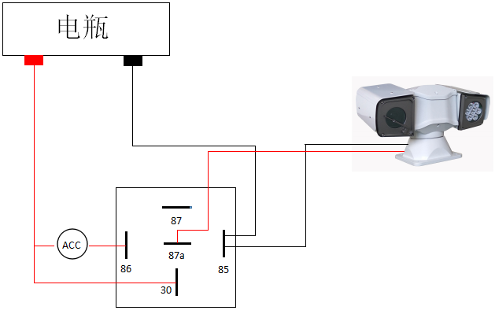

Description：

- The 85 and 86 pins of the relay are respectively connected to the negative pole of the car fuse box/the negative pole of the pan/tilt power cord and the ACC ignition switch.
- The 30-pin of the relay is connected to the normal power of the car.
- The 87a of the relay is connected to the positive pole of the power cord of the gimbal.

