Product model: MX-AHDX-TA4
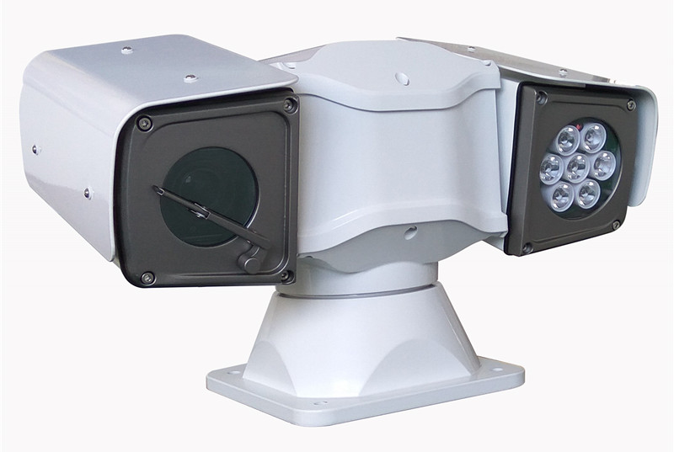

Features:
◎ Exquisite design, exquisite workmanship, precise circuit and rigorous structure, reflecting the highest technology;
◎The lens is adjustable, and the angle can be adjusted at will during the installation process;
◎Long viewing distance and wide viewing angle;
◎Waterproof sealed aluminum cover, using special waterproof treatment materials, reaches IP66 waterproof effect, suitable for outdoor use;
◎Integrated structure, shockproof and anti-loosening design;
◎Suitable for monitoring in various vehicle environments;
◎Image: positive image/mirror image;
◎Appearance color: white.

Specifications:
Specification | Power supply (optional) | DC12V I _{in} ≥4A
Specification | Power consumption | 35W
Specification | weight | 7Kg
Specification | Installation | Flat base installation
Specification | Relative humidity | 10-90%
Specification | Operating temperature | -35℃~55℃
Specification | Waterproof grade | IP66
Specification | Aperture & Zoom | Automatic/Manual
Basic functions of PTZ | Horizontal rotation | 100°/S max
Basic functions of PTZ | Rotate up and down | 60°/S max
Basic functions of PTZ | Preset position | Up to 256
Basic functions of PTZ | Patrol function | support
Basic functions of PTZ | Line scan speed | 0.5～30°/s
Infrared light | Infrared emitter | High brightness LED array x 7
Infrared light | wavelength | 850nm
Infrared light | Throw distance | 100 meters
Infrared light | Power consumption | 10W
Infrared light | Infrared light control | Automatic/menu manual control
Infrared light | Infrared lamp life | More than 20,000 hours

Specifications and dimensions:
