Product model：M22-NNNN
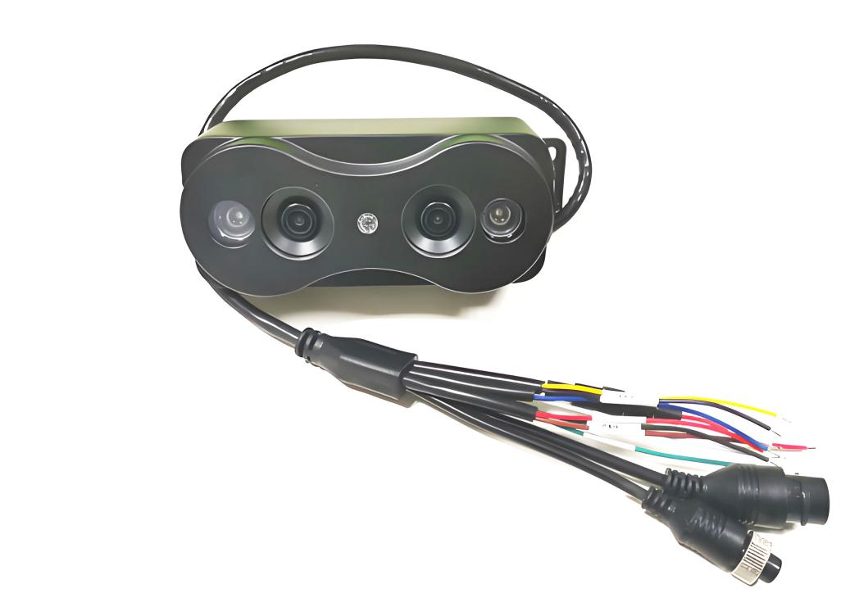

Features:
◎ Exquisite design, exquisite workmanship, precise circuit and rigorous structure, reflecting the highest technology;
◎ Equipped with dual camera modeling and detection function ;
◎Meet the needs of most passenger vehicles;
◎Image: positive image/mirror image;
◎Appearance color: black;
◎Specialized aviation interface design;

- System parameters

project | Equipment parameters | illustrate
 | Kernel system | L inux
system | Operating language | Chinese, English, Spanish (other languages can be customized)
system | User interface | C/S operation configuration method
system | Operating mode | Remote control, computer client, web

- Video parameters

project | Equipment parameters | Indicators
 | Image sensor | 1/3 CMOS​
Images and videos | Video format | PAL or NTSC standards (optional)
Images and videos | Horizontal resolution | 700 TV Lines
Images and videos | Preview function | Single-channel, two-screen splicing;
Images and videos | Video output | 1-channel video output (CVBS)
Images and videos | OSD | Images overlaid with information such as time, date, and passenger flow.
Images and videos | Compression format | H.264​
Images and videos | Lens parameters | 960*576 pixels, 2.8 mm (2.8mm/3.6mm/4mm/6mm optional)
Images and videos | Resolution | D1

- Alarm parameters

project | Equipment parameters | Indicators
Call the police | Enter | Two alarm I/O inputs, configurable for low-level alarms below 1V or high-level alarms above 4V .
Call the police | Functional alarm | Video loss, video obstruction, overload alarm

- Communication interface

project | Equipment parameters | Indicators
Communication interface | RS485 interface | One RS485 interface, supporting protocol integration and custom protocol development.
Communication interface | RJ45 | One RJ45 interface, which can be used for testing, copying, setting, recording, upgrading, and transmission.

- Electrical parameters

project | Equipment parameters | Indicators
Power supply and power consumption | Power input | 8V～36V. Please ensure your vehicle's power supply is within this range before use. Prolonged use above 36V will damage the machine.
Power supply and power consumption | Power on/off | Supports AC boot and delayed shutdown.
Power supply and power consumption | ACC  (Car key signal) | ≤4 V | Power off
Power supply and power consumption | ACC  (Car key signal) | ≥5 V | Power on
Power supply and power consumption | Output voltage | +12 V @0.5 A
Power supply and power consumption | Power  Consumption | Normal operating conditions <4 W

- Other parameters

project | Equipment parameters | Indicators
Other | Work environment | Temperature | -20 ℃ ~ 70 ℃
Other | Work environment | Humidity | 10 % ~ 90 % (non-condensing)
Other | Heat dissipation | No active cooling, using passive structural cooling.
Other | Size | 133X50X59.65mm (excluding mounting bracket)
Other | Total weight | Approximately 0.45 kg​
Other | Statistical precision | > 95 %

- Specifications and dimensions
