Product model: MX-AHDL-D30-NNP-005H
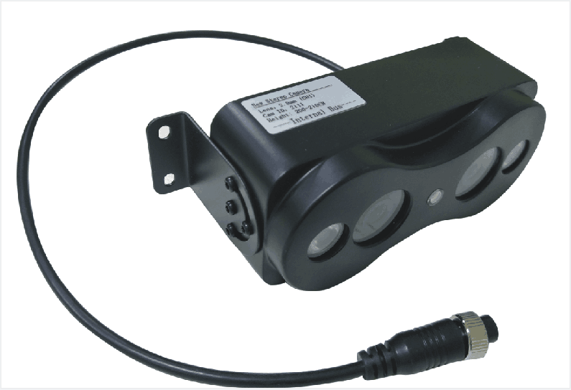
Features:
◎ Exquisite design, exquisite workmanship, precise circuit and rigorous structure, reflecting the highest technology;
◎ Equipped with dual camera modeling and detection function ;
◎Meet the needs of most passenger vehicles;
◎Image: positive image/mirror image;
◎Appearance color: black;
◎Specialized aviation interface design;

Parameters and specifications:
model | MX-AHDL-D30-NNP-005H
Image Sensor | 1/3 CMOS
Video format | PAL (PAL or NTSC optional)
Horizontal resolution | 700TVLines
Image Output | Synchronous sampling output
Lens spacing | 5cm (12cm is selected according to the detection range)
Lens parameters | 960×576 pixels, 2.8mm(2.1mm/2.8mm/3.6mm/4mm/6mm/8mm optional)
White Balance | Automatic white balance
shutter | 1/50-1/80000 (seconds) 1/60-1/80000 (seconds)
Frame rate | 25 fps
Video output interface | Composite video output, aviation head interface
Gain | Automatic Gain Control
Signal-to-Noise Ratio | ＞48db
power supply | 12V voltage input
power | ≤2W
size | 165×59.65×68mm (L×W×H)
weight | About 0.35KG
Operating temperature range | -20～+70℃
Relative humidity | 10%～90% non-condensing
Heat dissipation | No active heat dissipation, passive structural heat dissipation
Field of view | 2.8MM Horizontal: 105° Vertical: 60°

Dimensions:
