Model: MX-DSMM-839A-NNP-015H
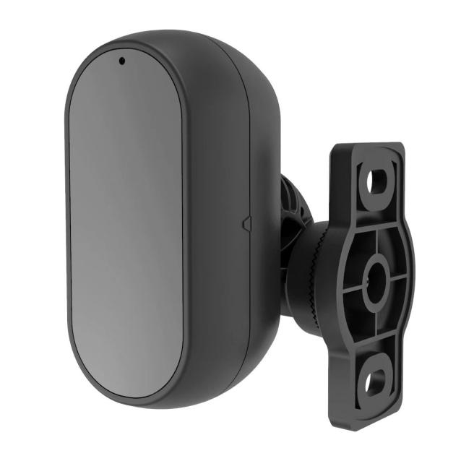
Features:
◎ Exquisite design, fine workmanship, precise circuitry and rigorous structure, reflecting the highest level of technology;
◎ Adjustable stand, allowing for angle adjustment;
◎ Focusing on driver behavior recognition ;
◎ Suitable for monitoring in various vehicle environments;
◎ Appearance color : Black;

Specifications:
Imaging devices | ISP: FH8536H |  | Sensor: GC2053
Standard | AHD PAL
Effective resolution | 1280 (H) x 720 (V)/1920 (H) x 1080 (V)
Effective pixels | 720P/1080 P
Synchronization System | Internal synchronization
Vertical synchronization frequency | 50Hz / 60Hz
Output image | DMS Black and White
Video output | 1.0vp-p, 75Ω
Gamma coefficient | 0.45
AGC | automatic
White Balance | automatic
lens | 4.0 mm
Lens angle | Horizontal angle | 80 °
Effective distance of infrared light | 1-2 meters​​
IR-CUT | none
audio | none
Current | 165 mA ± 10% ( DC12V )
Voltage | DC 6-16V
Operating temperature | - 20 °C~ 70 °C, RH95% MAX
Storage temperature | -30°C~80 ° C, RH95% MAX
Net weight | 182g

Wiring definition:
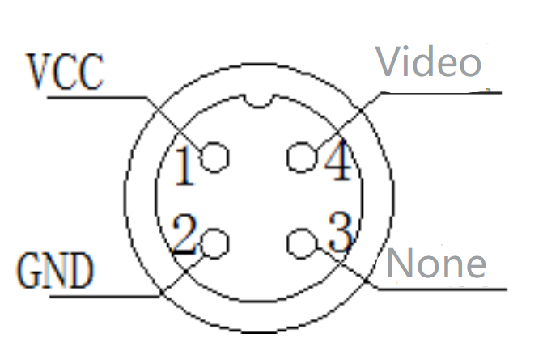
Product dimensions:
