Model:MX-DSMM-838A1-NNP-025H
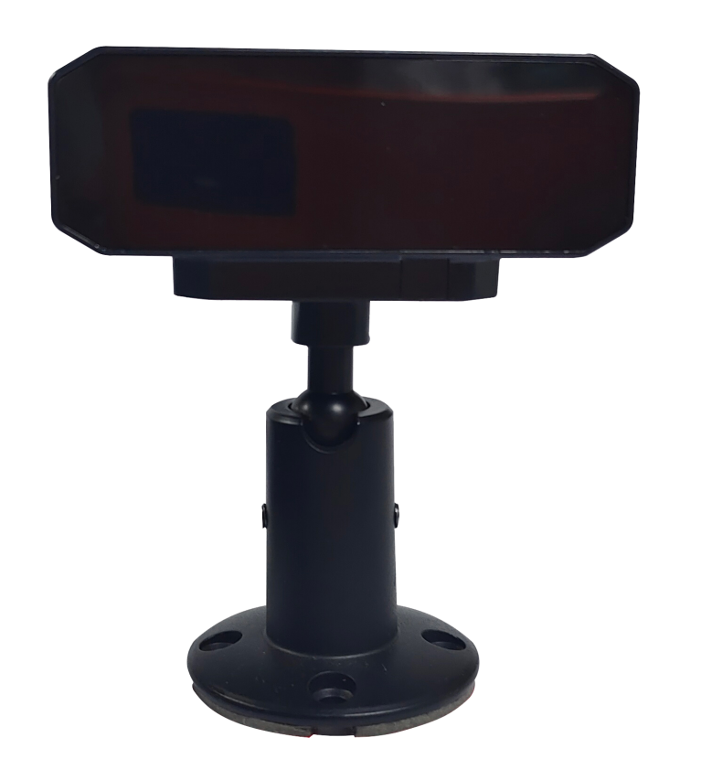
Features:
◎ Exquisite design, exquisite workmanship, precise circuit and rigorous structure, reflecting the highest technology;
◎Adjustable bracket, can adjust the angle;
◎ Focus on driver behavior recognition ;
◎Applicable to monitoring in various vehicle environments;
◎Image: positive image/mirror image;
◎Appearance color : black;
◎Specialized aviation interface design.

Specifications:
Model | MX-DSMM-838A1-NNP-025H
Module Type | FH8535+ 1/4” GC1084
resolution | AHD 720P
standard | PAL
Total pixels | PAL:1280(H)×720(V)
Minimum illuminance | 0.1LUX
Electronic Shutter | 1/50 ～ 1/100,000s
Signal-to-noise ratio | > 52dB
White balance | Automatic white balance
Day night switching | Black and white
Digital Wide Dynamic | Open
Mirror | Not enabled
UTC function | Turn on
Language | Default English
Video output | 1.0Vp-p composite output, 75 Ω
Lens | 3.9MM, 940 narrowband filter
Perspective | Horizontal 50 °
Interface | M12 quad core aviation interface (1:+12V, 2: GND, 3: air, 4: video)
Power supply | DC 12V±10%
Operating Temperature | -20℃～70℃
Operating Humidity | Relative humidity below 90%
Packaging | Accessory package, certificate of conformity

Product size:
