Model：MX-ADASH-831A-NNP-025V
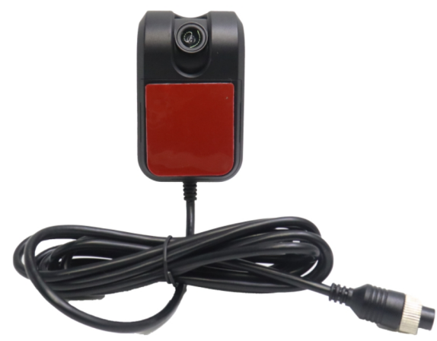

Product feature
1.Exquisite design, exquisite workmanship, precise lines and rigorous structure, reflecting the highest technology;
2.Integrated structure, shockproof, dust-proof;
3.ADAS specific camera，suitable for all kinds of vehicles；
4.Adjustable lens angle；
5.Sticker Installation；
6.Dedicated aviation interface design；

Specification
Model | MX-ADASH-831A-NNP-025V
Shell shape | Plastic shell
Exterior color | Black
Imaging | 1/2.9-inch 1080P CMOS
Infrared | \
Effective pixels | 1920(H)*1080(V)
Minimum Illumination | 0.01 LUX/F1.2
Horizontal clarity | AHD 1080P
Scanning frequency | 25Hz
Audio | \
Video output | 1.0V
White balance | Automatic
Shutter | 1/50～1/100000s
Signal-to-noise ratio | >46dB
Current | Infrared does not activate 65mA/ without infrared
Voltage | DC 12V±10%
Protection level | IP65
Working environment | Temperature -20 º C~75 º C，Humidity -0 º C~90 º C
Camera angle | Lens: 6mm，Horizontal: 50 °
Usage environment | Inside the car
Connection connector | M12

Size:
