Product Model: MX-AHDH-806A-NNP-005H
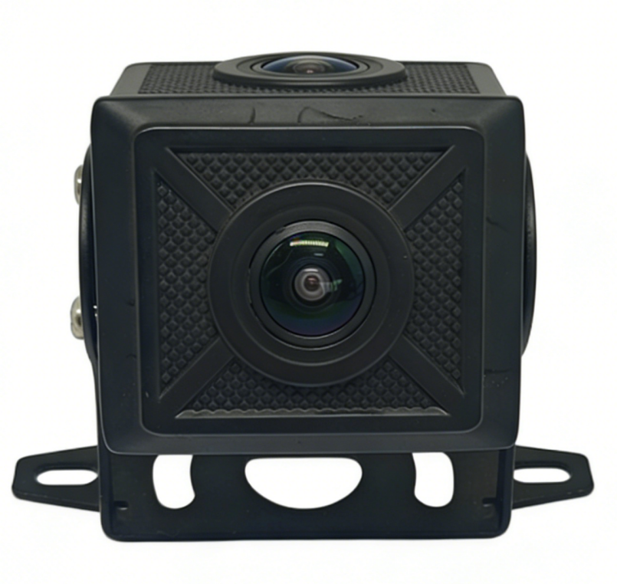
Features:
◎Exquisite design, fine workmanship, precise circuitry and rigorous structure, reflecting the highest level of technology;
◎Integrated structure with shock-resistant and anti-loosening design;
◎Suitable for monitoring in various vehicle-mounted environments;
◎Appearance color: Black;
◎Dedicated aviation interface design

Specifications:

Imaging devices | 1/ 2.9 CMOS
Standard | PAL
Resolution | 1080P
Pixels | 1 920 (H) * 1080 (V)
Shutter speed | Automatic: 1/50 - 1/100,000 (s)
Minimum Illumination | 0.01 Lux
Video format | AHD
Wide dynamic range | none
aperture | F2.2
Signal-to-noise ratio | Greater than 50 dB
White Balance | AUTO
Backlight compensation | automatic
lens | 2.8 mm/ 3.6mm
Horizontal angle of the lens | 100 ° / 85 °
audio | none
Protection level | IP68
power | ≤3W
Voltage | DC 12V±10%
Operating temperature | -20°C to 70°C
Storage temperature | -30°C to 80°C

Product Specifications:
