Model: MX-AHDH-803-NNP-WIFI-H , 2.8mm
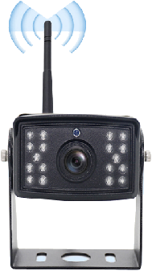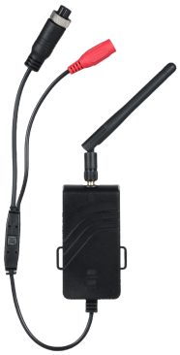

Features:
- Low power consumption and easy heat dissipation;
- Wide viewing angle, adjustable stand,
- Provide indoor and outdoor sun protection;
- Waterproof grade, IP6 6 ;
- Integrated structure, shockproof and anti-loosening design;
- Applicable to various vehicle monitoring environments
- Color: Black;
- Suitable aviation connector design;

Specification:
Model | MX-AHDH-803-NNP-WIFI-H
Wireless Camera
Image Sensor | 1/2.9 inch CMOS
Image resolution | 2MP
Image pixels | 1920(horizontal)*1080(vertical)
Video frame rate | 1080p@25fps or 30fps
Minimum illumination | Color: 0.01Lux, Black and White: 0.001Lux, 0Lux (infrared on)
lens | 2.8mm 2MP IR plate lens (90°)
Horizontal angle of view | 100°
day and night | Automatic (ICR) / Color / Black and White
Infrared LED | 16 LED arrays
Infrared distance | 10-15 meters
Wide dynamic range | Wide dynamic range
Wireless | Built-in 2.4GHz wireless signal receiver
Operating temperature | -20 ⁰ C-70 ⁰ C
power supply | DC 12V±20%
shell | IP66 rated black metal housing
2.4G HD wireless waterproof receiver
power supply | DC12V-24V
Emission current | 300 mAh
Video Output | 720P (HD)
Operating frequency | 2400-2483.5MHz
Transmission distance | 500m open space
Startup time | 3 seconds
Transmission power | 12Mbps
Pair | automatic
Sound | No
Water proof | IP66
Delay time | 9-120 ms
Operating temperature | -20 ～ 70 ℃ RH95% or less
Storage temperature | -30 ～ 80 ℃ RH95% or less
Shell | Black plastic housing
Aspect | 80(length)*40(width)*18(thickness)mm
Red light on/off | Power on/off
Flashing red light | Pairing
Green light on | Connection successful
Green light off | Signal loss

