Model: MX-AHDH-701A-NNP-005H
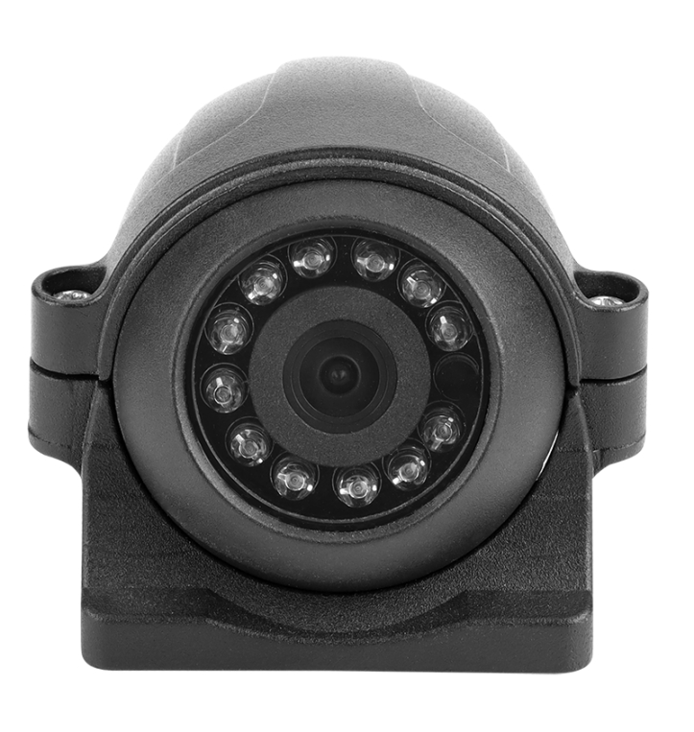
Features:
◎Low power consumption, easy heat dissipation; good color reproduction, clear picture quality;
◎Exquisite, beautiful and fashionable appearance;
◎Fashionable appearance; high strength, highly resistant to impact damage;
◎ Using 9 imported high-power LED lights, shooting distance 10 m;
◎Infrared automatically turns on when the light is lower than 10Lux;
◎Adopt imported lens to prevent water vapor from affecting the image;
◎Appearance color: black ;
◎ Waterproof grade: IP67 ;
◎Specialized aviation interface design .

Specifications:
Model | MX-AHDH-701A-NNP-005H
Image Sensor | 1/4″ CMOS AHD
Resolution | 1080P/720P
Signal system | PAL / NTSC​
Pixel | 1920 ( H) x 1080(V)
Lenses | 2.8mm/3.6mm
Horizontal angle of view | 100°/80°
Minimum illumination | 0.001 ( Lux ) (Infrared on)
Backlight compensation | built-in
Shutter speed | 1/50~1/10000 seconds ( P ) 1/60-1/10000 seconds ( N )
White Balance | automatic
Signal-to-Noise Ratio | Greater than 50db (AGC OFF)
Video Output | AHD , amplitude 1Vp-p, 75Ω
Power supply | Rated DC12V±10%
Power consumption | Infrared light on Infrared light off ≤ 3W
Operating temperature | -20 ℃ ~ +70℃
Infrared wavelength | 850nm
Number of infrared lights | Φ 5 12LED lamp
Infrared light irradiation distance | 5M
Infrared light illumination | ＞3Lux
Jack | M12 aircraft carrier head (with O -ring)
Dimensions | 90mm*77.5mm*62mm

Dimensions:
