Model：MX-AHDL-610A-NNP-005H
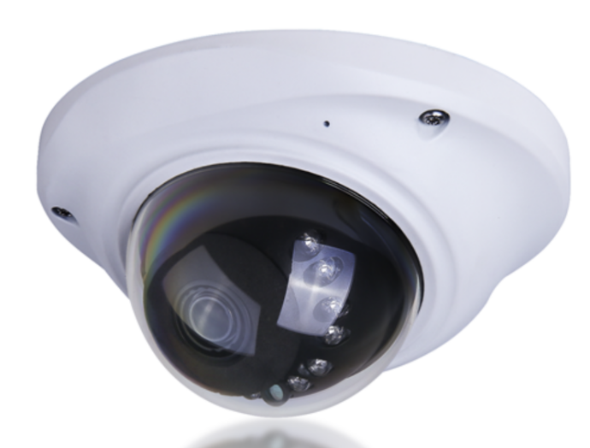

Product feature
1.Exquisite design, exquisite workmanship, precise lines and rigorous structure, reflecting the highest technology;
2.Integrated structure, shockproof, dust-proof, anti-fog design;
3.Suitable for all kinds of vehicles；
4.Image: positive/mirror image；
5.Color: white;
6.Dedicated aviation interface design；

Specification
Model | MX-AHDL-610A-NNP-005H
Image Sensor + DSP | 1/2.7″ CMOS AHD
Picture Pixels | 1920(H)*1080(V)
Video Frame Rate | PAL: 1080p@25fps, NTSC: 1080p@30fps
Video Output | AHD
Transmission Distance | More than 500m via 75-3 coaxial cable
Minimum Illumination | Day: 0.01Lux, 0Lux (IR ON)
Lens | 2.8mm
Horizontal angle of view | Optional 90°/100°/105°
Sync System | Internal Synchronization
Electronic Shutter | PAL: 1/25 -1/50,000 Sec, NTSC: 1/30 -1/60,000 Sec
S/N Ratio | More than 50dB
Day and Night | Auto (ICR) / Color / B/W
Infrared LED | 12mil*Φ5*12pcs LEDs
IR Distance | 10-15m
OSD Menu | Support
UTC | Support
OSD/UTC Language | EN, CN, DE, FRA, IT, ES, PL, RU, PT, NL, TR
D-WDR | Support
Noise Reduction | 3D NR
White Balance | Auto / Manual
Gain Control | Auto
Operation Temperature | -20°C~+70°C / Less than 95%RH (No condensation)
Power Supply | DC12V+/-20%
Dimension | Φ120*62mm
Housing | Ivory color metal case

Size:
