Model: MX-AHDH-301A-NNP-005H
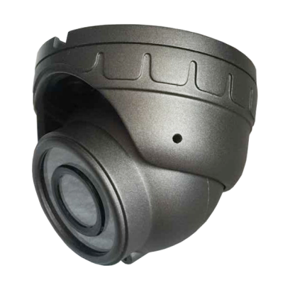
Product features:
- Low power consumption, easy dissipate heat;
- Good color reduction and picture quality;
- Mini conch construction, Exquisite, beautiful and fashion;
- High hardness, Anti-collision;
- Built in imported 12 pcs Φ5 IR LED lights, 5m shooting distance;
- Infrared function auto on when light lower than 10Lux;
- Use imported lens plate, good moisture-proofing;
- Color: gray;
- Appropriative aviation connector design;

Specifications:
Model | MX-AHDH-301A-NNP-005H
Image sensor | 1/2.9” Aptina 0130 with Nextchip2431
Resolution | 1080P/720P
Signal system | PAL/NTSC
Pixel | PAL/NTSC：1920（H) x 1080(V)/1280（H) x 720(V)
Lens | Standard 2.8mm/3.6mm lens
Horizontal angle of view | 105°/80°
Minimal illumination | 0Lux
Backlight compensation | Built-in
Shutter speed | 1/53~1/100,000 sec
White balance | Automatic tracking
Noise-signal ratio | ＞50db (AGC OFF)
Video output | 1.0Vp-p,75Ω
Power | DC12V±10%
Consumption | ≤3W
working temperature | -20℃~ +70℃
Infrared wavelength | 850nm
Infrared lamp quantity | Φ5 12LED light
Infrared lamp Irradiation distance | 5M
Infrared lamp turn on brightness | ＞3Lux
Connector | VIDEO OUT (Appropriative aviation connector)
Size | Φ68.8mm*59.2mm

Size：
