Product Model: MX-AHDM-267A-NNP-005H
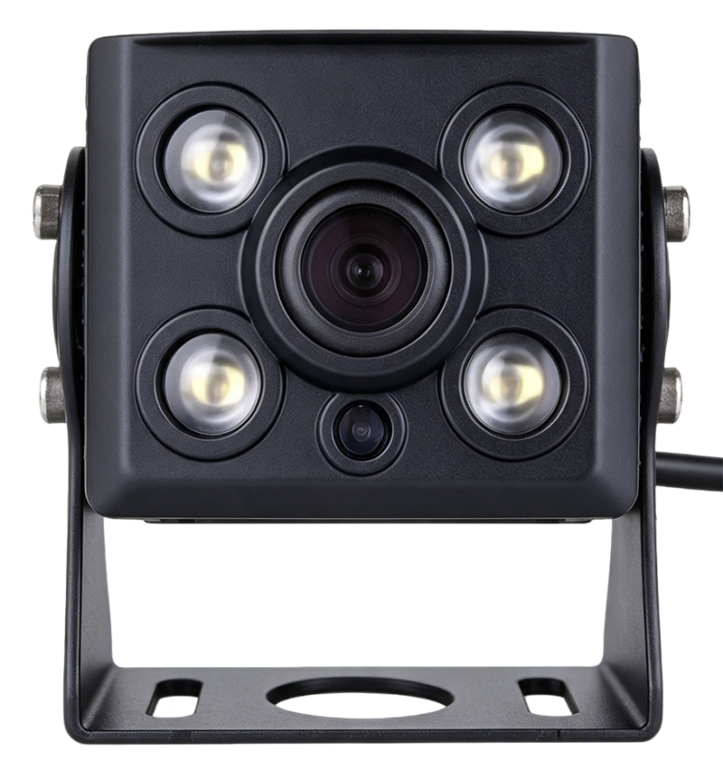

Features:
- 1/ 2.9 " CMOS
- Resolution: 1280*720L
- Minimum illuminance: 0.01 Lux
- Automatic electronic shutter, automatic exposure, automatic white balance
- Supports 2.1 mm field of view lenses
- Night vision: Infrared night vision
- Waterproof, suitable for outdoor installation

Specifications:
Product Model | MX-AHDM-267A-NNP-005H
Imaging devices | 1/ 2.9 " CMOS
resolution | 720P
Standard | P-system/25 frames
Minimum Illumination | 0.01 lux
Synchronization System | Internal synchronization
Scanning System | line scan
Signal-to-noise ratio | ≥50dB
Electronic shutter | 1/25 to 1/25,000 of a second (automatic)
Filter type | Color box black and white switching
White Balance | Automatic white balance tracking
Automatic gain | support
3D noise reduction | support
Backlight compensation | support
angle | Field of view: Diagonal: 140 ° , Horizontal: 120 ° , Vertical: 68 °
Image mode | Colored bricks black and white
Video output | 1.0Vp-p composite video output, 75 ohms, 4-pin aviation cable
power supply | DC12V -24V
Power consumption | Maximum 300mA/DC12V±5%
Operating temperature | -30°C ~ 75°C
Operating humidity | Humidity less than 95% (no condensation)
Waterproof rating | IP68
Installation method | bracket installation
audio | No audio

Size specifications :
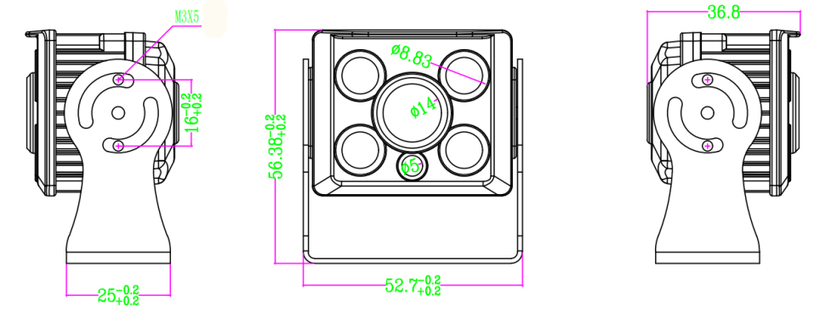
Wiring definition:
