Product Model: MX-AHDH-266A-NNP-005H
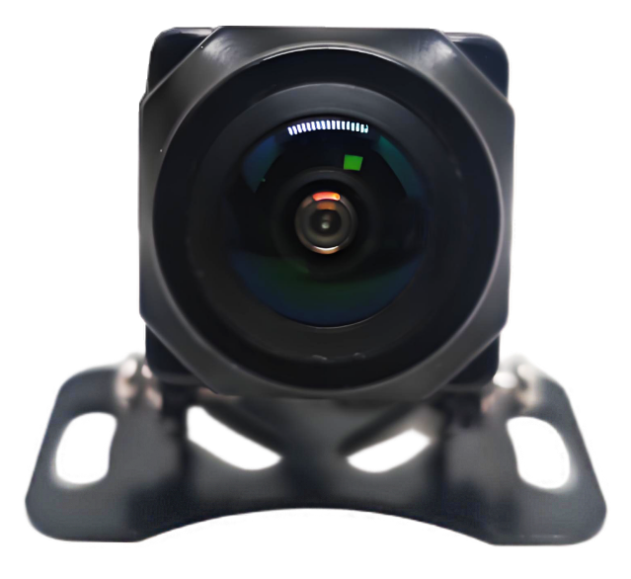

Features:
◎ 1/2.9″ high-resolution CMOS sensor
◎ 1080P Ultra HD Camera
◎ Supports automatic white balance
◎ Supports low-light night vision down to 0.01 Lux
◎ Horizontal angle of the lens: 165°
◎ Compact design supports better waterproofing
◎ Multiple mounting holes for quick installation
◎ Appearance color: Black;

Specifications:
Model | MX-AHDH-266A-NNP-005H
plan | FH8536+2053
Image sensor | 1/2.9″ CMOS AHD
Resolution | 1080P
Signal System | PAL system
Pixels | 1920 (H) x 1080 (V)
lens | 1.58mm lens
Horizontal | 165°
Minimum Illumination | 0.01 Lux
Backlight compensation | automatic
Shutter speed | Automatic: 1/50 to 1/100,000 (seconds)
White Balance | Automatic white balance tracking
Wide dynamic range | none
Signal-to-noise ratio | Greater than 55dB (AGC OFF)
Video output | 1.0Vp-p, 75Ω
power supply | DC12V±10%
Power consumption | ≤3W
Operating temperature | -20℃ ~ +70℃
Infrared wavelength | /
Number of infrared lights | /
Infrared light illumination distance | /
Infrared light illuminance | /
Interface | M12 aircraft carrier bow (with O-ring)
External dimensions | 41*40*31 (mm)

Size specifications :
