Product Model: MX-AHDH-115B-NNP-005, 2.1mm
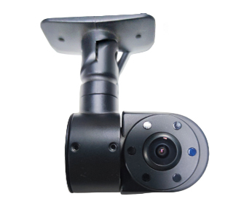
Features:
◎Exquisite design, fine workmanship, precise circuitry and rigorous structure, reflecting the highest level of technology;
◎Special strong adhesive design for easy installation;
◎The rotatable lens allows for adjustment of the shooting angle;
◎ Meets the needs of most commercial vehicles;
◎Image: Orthogonal/Mirror Image;
◎Appearance color: Black;

Specifications:
Plan | 8536H+2053
Image sensor | 1/2.9″ CMOS AHD
Image resolution | 1080P
Signal system | PAL
Pixels | 1920 (H) x 1080 (V)
lens | 2.1mm
Maximum angle | 130°
Minimum Illumination | 0Lux
Backlight compensation | built-in
Shutter speed | automatic
White alance | Automatic white balance tracking
Wide dynamic range | none
Signal-to-noise ratio | Greater than 50dB (AGC OFF)
Video output | 1.0Vp-p, 75Ω
Audio | Optional
Power supply | DC12V±10%
Power consumption | Infrared light on/off ≤3W
Operating temperature | -20℃ ~ +70℃
Infrared wavelength | 850
Number of infrared lights | 5
Infrared light illumination distance | 0-3 meters
Infrared light illuminance | 0LUX
Interface | BMW Connector

Size specifications:
