Product Model: MX-AHDH-113A-AXP-005, 2.8mm
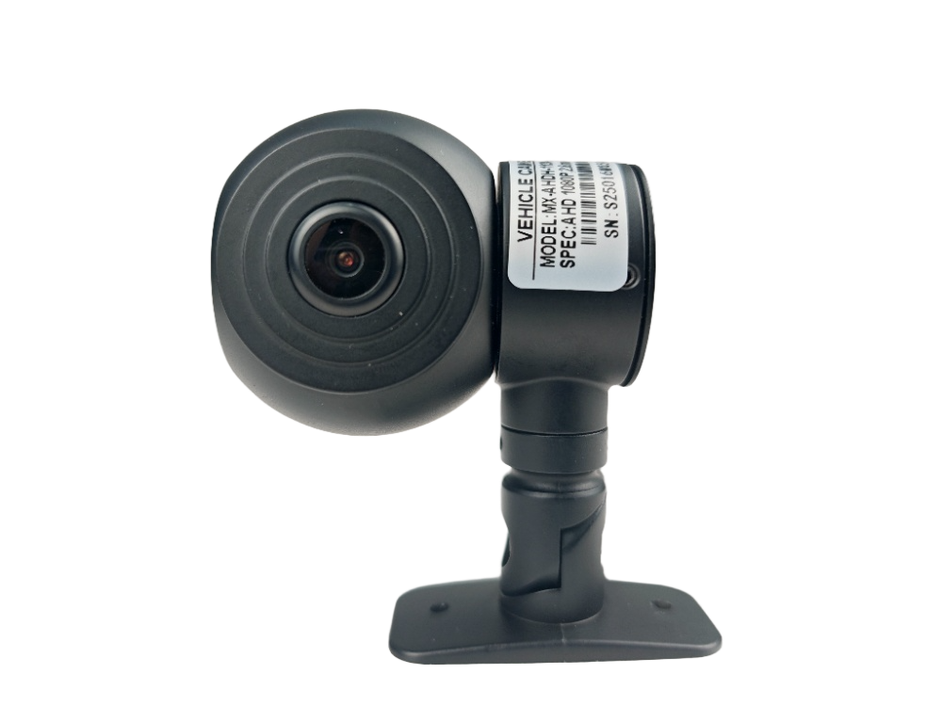
Features:
◎ Exquisite design, exquisite workmanship, precise circuit and rigorous structure, reflecting the highest technology;
◎Specialized strong adhesive design, easy to install;
◎Rotatable lens allows you to adjust the shooting angle;
◎Meet the needs of most commercial vehicles;
◎Image: positive image/mirror image;
◎Appearance color: black;
◎Specialized aviation interface design;

Parameters and specifications:
Plan | FH8333+IMX662
Image sensor | 1/2.8″ SONY AHD
Resolution | 1080P
Signal system | PAL system
Pixel | 1920（H) x 1080(V)
lens | 2.8mm lens
Camera angle | 100°
Minimum illumination | 0.01Lux
Backlight compensation | automatic
Shutter speed | Automatic: 1/50~1/100,000 (seconds)
White Balance | Auto tracking white balance
Wide dynamic range | Greater than 120DB
Signal-to-noise ratio | Greater than 50db
Video Output | 1.0Vp-p,75Ω
power supply | DC12V±10%
Power consumption | ≤3W
Operating temperature | -20℃ ~ +70℃
Infrared wavelength | /
Number of infrared lights | /
Infrared light irradiation distance | /
Infrared light illumination | /
Interface | M12 aircraft carrier head (with O-ring)
Dimensions | 72mm*58mm*78mm

Dimensions:
