Model: MX-AHDH-110B-ANP-015,2.8mm
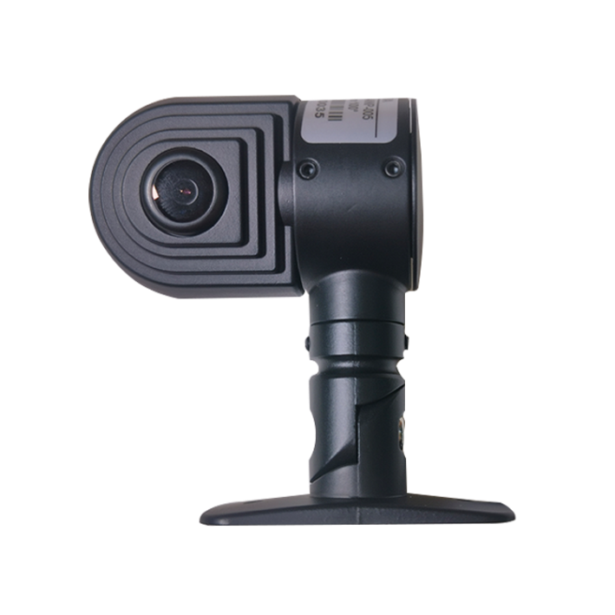
Product feature
- Exquisite design, exquisite workmanship, precise lines and rigorous structure, reflecting the highest technology;
- Dedicated 3M superglue design；
- Integrated structure, shockproof, dust-proof, anti-fog design;
- Suitable for all kinds of vehicles；
- Image: positive/mirror image；
- Color: black;
- Dedicated aviation interface desig-110A/BMW CIC head-110B；

Specifications:
Project | Parameter
Model | MX-AHDH-110B-ANP-015,2.8mm
Chip | 1/2.9″ CMOS
Resolution | 1080P AHD
Signal system | PAL
Image source | AHD
Pixel | 1920(H) x 1080(V)
Shot | 2.8mm
Horizontal angle | 100°
Minimum illumination | 0Lux
Backlight Compensation | built-in
Shutter speed | 1/53~1/100,000（S）
Interface | BMW head interface
White balance | automatic tracking
Signal to Noise Ratio | >50db (AGC OFF)
Video output | 1.0Vp-p,75Ω
Power supply | DC12V±10%
Operation temperature | -20℃ ~ +70℃
Size | 58mm*34mm*71mm

Size
