TTS Voice Broadcast Specification
Model: MX-TTS-01-01
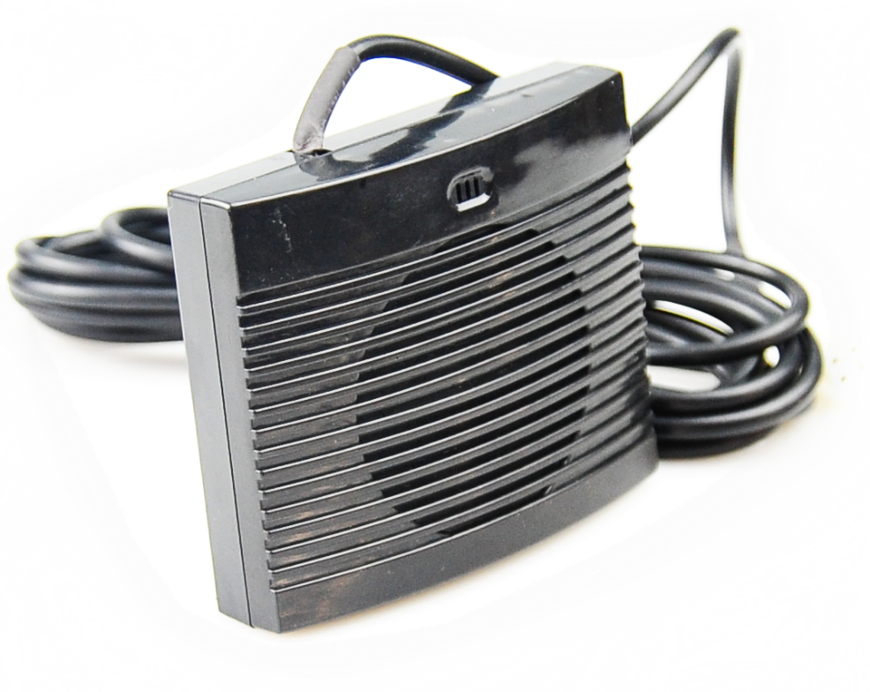

parameter
Item | Parameters
Function | Support Chinese and English and mixed reading
Composite text size | Maximum 4K bytes supported
Property | volume、speed adjustable
Interface | RS232 interface
Baud rate | 4800
Operating temperature | -20-70°C
Power input | DC 5V/0.05A
Power protection | Support Anti-reverse protection function
Consumption | 0.25W
Function | Support Chinese and English and mixed reading
Size | 91*76.6*25.2mm

