Taxi meter
Model：MX-Ha-01

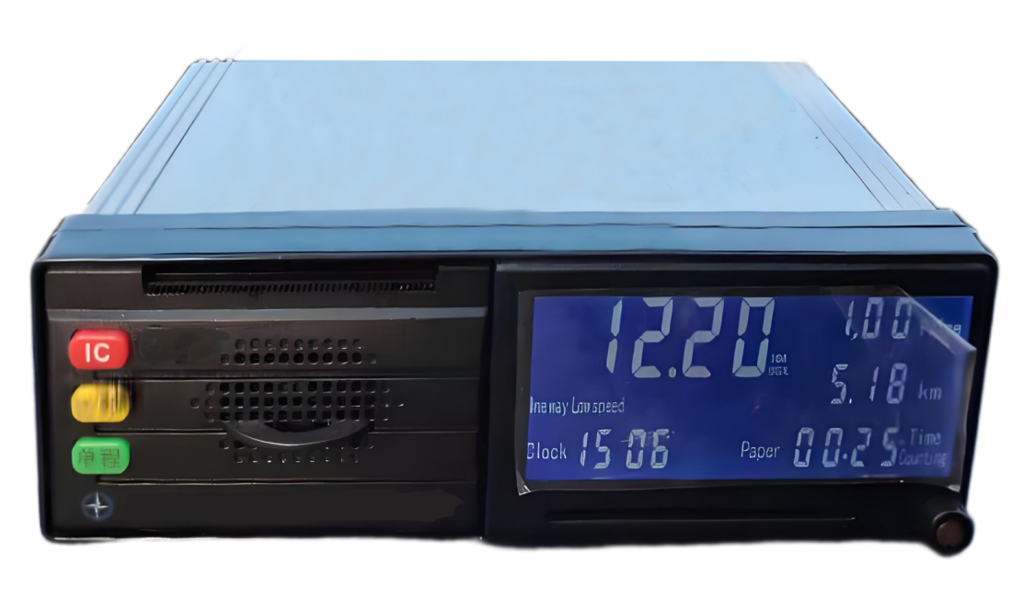
Product Introduction
The unique operation management function of this product effectively utilizes the intelligent advantages of the meter and hardware resources such as IC card readers and writers, combined with the designed taxi operation management software. It can transmit management information to the meter, collect and process operation information, and implement operation management, supervision, inspection, etc. This system can make the management of the taxi industry more scientific, efficient, and standardized.

- LCD display function
- Printing function
- Voice function
- Normal operation function at low temperature
- Operational pricing function
- Clock calibration function
- Data collection function

Product parameters
Item | Description
Calculation error | ± 0.5%
Timing error | ± 0.2%
Switching speed error | ± 0.5km/h
Permanent clock error | ± 5s/d
Working voltage | DC +9V～16V
Working current | ≤ 150mA (excluding empty car light on)
Current during printing | Needle printer ≤ 500mA Thermal printer ≤ 1500mA
Working conditions | Temperature range of -20 ℃ to+70 ℃
Humidity | ≤ 90% RH
Storage conditions | Temperature -40 ℃ to+80 ℃
Humidity | ≤ 90% RH

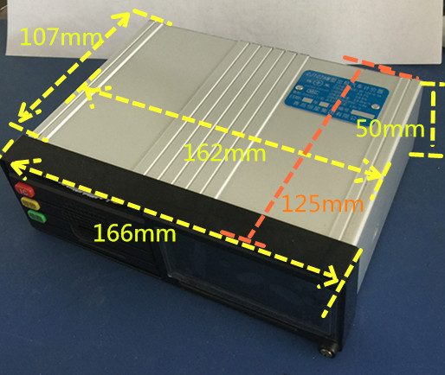
Product size

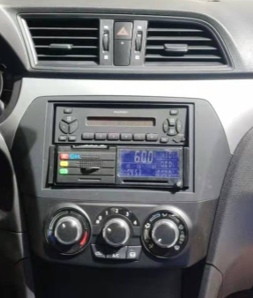
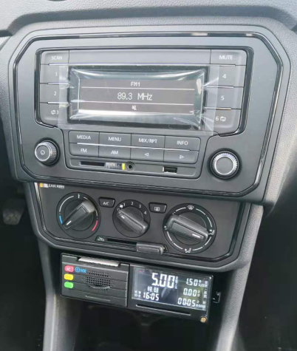
Installation matters

