Double-sided empty roof screen
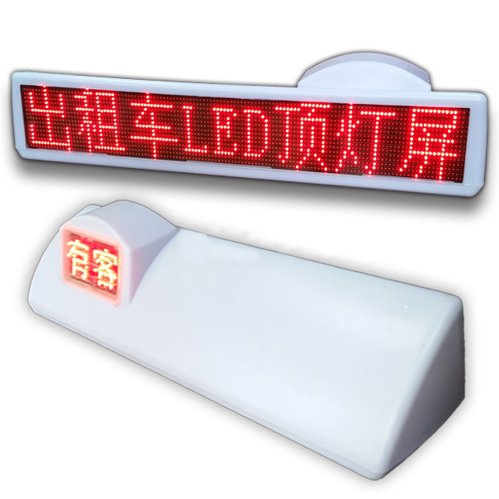

Parameters
NO. | Item | Description
Pixel tube | Dot pitch | 7.62*6mm
Pixel tube | Pixel tube chip | Taiwan Opto Lei
Pixel tube | Luminous point color | 1 yellow/red（9mil）
Pixel tube | Density | 27800点
Pixel tube | Base color | Red/Yellow
led | Center wavelength | Brightness | led
Pure Red R | 625 | 1800mcd | Pure Red R
Cell board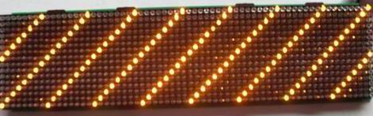 | Module size | 768x122mm
 | Number of rows and columns of unit board | Wide 128 point× Hight 16 point
 | Resolution | 27800/ m²
 | Column driver IC | 74HC5026
 | Row driver IC | 74HC4953
 | Main control chip | 74HC245
 | Relative temperature | -40~+80℃
 | Operating Voltage | 9-36V 50HZ
 | Average power consumption | 25W
Main technical parameters | Drive way | 1/8
Main technical parameters | Refresh rate | ≧100HZ
Main technical parameters | Gray scale | No
Main technical parameters | Color | Yellow/Red
Main technical parameters | Video input/output method | 3G wireless network transmission
Main technical parameters | Service life | ≧80000h
Product Size | frame size | 830*195*230mm
Product Size | display size | Front：170*120mm  Rear：765*125mm

