Sound and Light Alarm Product Specifications

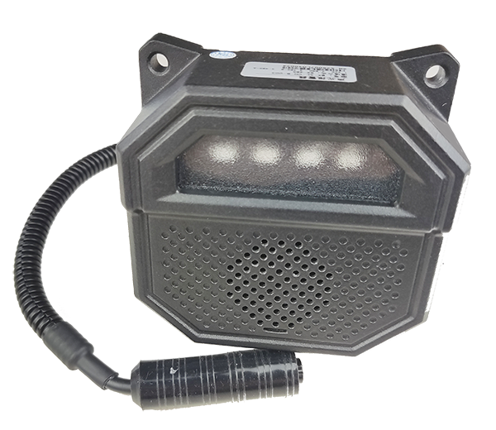

1. Product Introduction:
MX-SL-CH-B-003 is an audible and visual alarm used in many fields.It adopts wide voltage DC 9-36V input . It has built-in high-brightness LED and 5W high -power speaker, which can realize voice broadcast and strobe light alarm.
All-metal die-cast aluminum housing, industrial appearance design , waterproof and dustproof up to IP67 , can be used in various complex environments.
Second, product features:
• Industrial appearance design, using new heat dissipation materials, long product life
• Use high-quality and high-brightness light source to effectively reduce light attenuation
•Warm light design, strong penetrating power of haze , novel and unique light design, energy-saving and environmentally friendly
• The housing protection grade reaches IP67.
• Supports wide voltage input 9-36V , stable performance .
• Industrial grade working temperature -20 degrees -70 degrees, stable operation.
• Color can be customized.

3. Product size: (unit: MM )
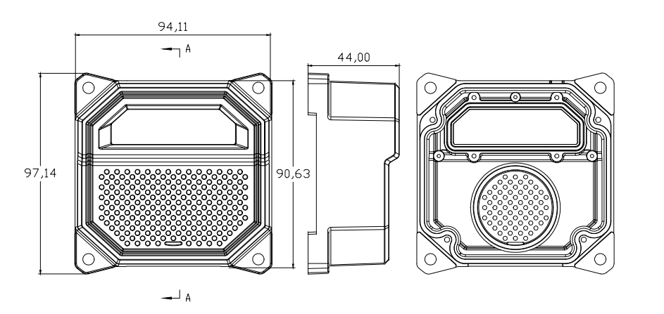
4. Product connector definition
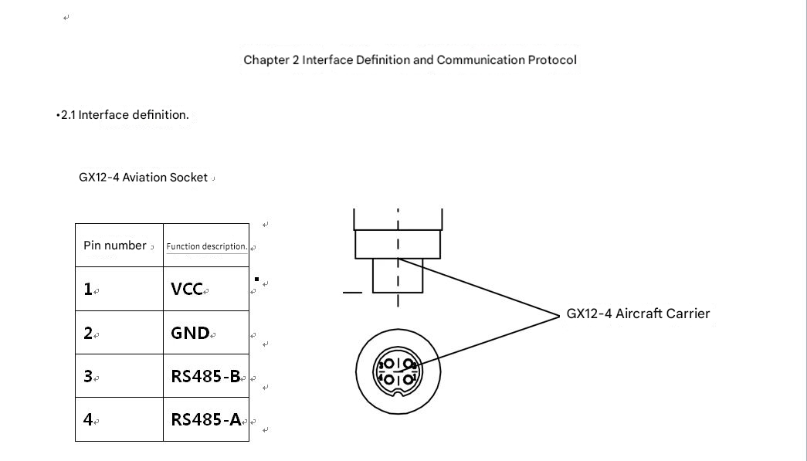
5. Product Specifications
model | MX-SL-CH-B-003
Operating voltage | DC : 9V - 36V​
Operating temperature | - 20 degrees ~ +70 degrees
Working current | Static <50mA ; Dynamic MAX <1A
Maximum Power | 13W
Communication interface | RS485
Communication baud rate | 9600bps
Alarm method | Sound and light alarm
Luminous form | LED strobe light
Speaker power | 5W
Color Display | Dual color, red/green
Interface | Aviation head GX12-4 female socket (customizable)
Line length | 0.3m​
Installation fixing holes | 4 fixing holes
Waterproof and dustproof level | IP67
Shell material | Aluminum Alloy
size | See dimensional drawing
weight | 380 g
Shell color | Black, (other colors can be customized)

6.Communication Protocol
- Basic format of communication protocol
Header  field | Address field | Functional domain | Data length | Data  Field | CRC Check | Packet trailer field
2bytes | 1 byte | 1 byte | 2 bytes | Nbytes | 2 bytes | 2 bytes
Note: Baud rate 9600, n,8,1
Device default address 0x01
Packet header 0x aa55
Packet tail 0x 55aa
Data format: big endian mode, for example, the data length is 1 byte and the data sequence is 0x 00 0x01 , high byte first, low byte second, and low byte third.
CRC check : Data in the address field-data field (before the CRC check field) participates in the CRC check
- Return command
Function domain or 0x80 , returned according to the basic format of the communication protocol, for example, if the function domain is 0x01, the corresponding function domain returned is 0x81
- Basic command format
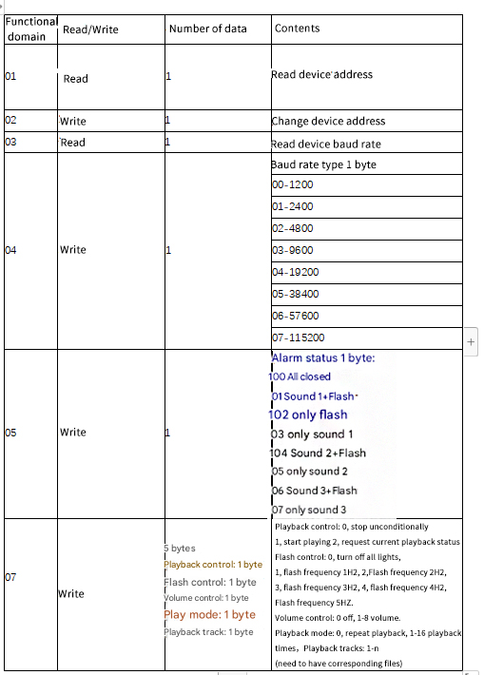

7.CRC check algorithm (C language)
uint8_t auchCRCHi[]=
{
0x00, 0xC1, 0x81, 0x40, 0x01, 0xC0, 0x80, 0x41, 0x01, 0xC0, 0x80, 0x41, 0x00, 0xC1, 0x81,
0x40, 0x01, 0xC0, 0x80, 0x41, 0x00, 0xC1, 0x81, 0x40, 0x00, 0xC1, 0x81, 0x40, 0x01, 0xC0,
0x80, 0x41, 0x01, 0xC0, 0x80, 0x41, 0x00, 0xC1, 0x81, 0x40, 0x00, 0xC1, 0x81, 0x40, 0x01,
0xC0, 0x80, 0x41, 0x00, 0xC1, 0x81, 0x40, 0x01, 0xC0, 0x80, 0x41, 0x01, 0xC0, 0x80, 0x41,
0x00, 0xC1, 0x81, 0x40, 0x01, 0xC0, 0x80, 0x41, 0x00, 0xC1, 0x81, 0x40, 0x00, 0xC1, 0x81,
0x40, 0x01, 0xC0, 0x80, 0x41, 0x00, 0xC1, 0x81, 0x40, 0x01, 0xC0, 0x80, 0x41, 0x01, 0xC0,
0x80, 0x41, 0x00, 0xC1, 0x81, 0x40, 0x00, 0xC1, 0x81, 0x40, 0x01, 0xC0, 0x80, 0x41, 0x01,
0xC0, 0x80, 0x41, 0x00, 0xC1, 0x81, 0x40, 0x01, 0xC0, 0x80, 0x41, 0x00, 0xC1, 0x81, 0x40,
0x00, 0xC1, 0x81, 0x40, 0x01, 0xC0, 0x80, 0x41, 0x01, 0xC0, 0x80, 0x41, 0x00, 0xC1, 0x81,
0x40, 0x00, 0xC1, 0x81, 0x40, 0x01, 0xC0, 0x80, 0x41, 0x00, 0xC1, 0x81, 0x40, 0x01, 0xC0,
0x80, 0x41, 0x01, 0xC0, 0x80, 0x41, 0x00, 0xC1, 0x81, 0x40, 0x00, 0xC1, 0x81, 0x40, 0x01,
0xC0, 0x80, 0x41, 0x01, 0xC0, 0x80, 0x41, 0x00, 0xC1, 0x81, 0x40, 0x01, 0xC0, 0x80, 0x41,
0x00, 0xC1, 0x81, 0x40, 0x00, 0xC1, 0x81, 0x40, 0x01, 0xC0, 0x80, 0x41, 0x00, 0xC1, 0x81,
0x40, 0x01, 0xC0, 0x80, 0x41, 0x01, 0xC0, 0x80, 0x41, 0x00, 0xC1, 0x81, 0x40, 0x01, 0xC0,
0x80, 0x41, 0x00, 0xC1, 0x81, 0x40, 0x00, 0xC1, 0x81, 0x40, 0x01, 0xC0, 0x80, 0x41, 0x01,
0xC0, 0x80, 0x41, 0x00, 0xC1, 0x81, 0x40, 0x00, 0xC1, 0x81, 0x40, 0x01, 0xC0, 0x80, 0x41,
0x00, 0xC1, 0x81, 0x40, 0x01, 0xC0, 0x80, 0x41, 0x01, 0xC0, 0x80, 0x41, 0x00, 0xC1, 0x81,
0x40
};

uint8_t auchCRCLo[] =
{
0x00, 0xC0, 0xC1, 0x01, 0xC3, 0x03, 0x02, 0xC2, 0xC6, 0x06, 0x07, 0xC7, 0x05, 0xC5, 0xC4,
0x04, 0xCC, 0x0C, 0x0D, 0xCD, 0x0F, 0xCF, 0xCE, 0x0E, 0x0A, 0xCA, 0xCB, 0x0B, 0xC9, 0x09,
0x08, 0xC8, 0xD8, 0x18, 0x19, 0xD9, 0x1B, 0xDB, 0xDA, 0x1A, 0x1E, 0xDE, 0xDF, 0x1F, 0xDD,
0x1D, 0x1C, 0xDC, 0x14, 0xD4, 0xD5, 0x15, 0xD7, 0x17, 0x16, 0xD6, 0xD2, 0x12, 0x13, 0xD3,
0x11, 0xD1, 0xD0, 0x10, 0xF0, 0x30, 0x31, 0xF1, 0x33, 0xF3, 0xF2, 0x32, 0x36, 0xF6, 0xF7,
0x37, 0xF5, 0x35, 0x34, 0xF4, 0x3C, 0xFC, 0xFD, 0x3D, 0xFF, 0x3F, 0x3E, 0xFE, 0xFA, 0x3A,
0x3B, 0xFB, 0x39, 0xF9, 0xF8, 0x38, 0x28, 0xE8, 0xE9, 0x29, 0xEB, 0x2B, 0x2A, 0xEA, 0xEE,
0x2E, 0x2F, 0xEF, 0x2D, 0xED, 0xEC, 0x2C, 0xE4, 0x24, 0x25, 0xE5, 0x27, 0xE7, 0xE6, 0x26,
0x22, 0xE2, 0xE3, 0x23, 0xE1, 0x21, 0x20, 0xE0, 0xA0, 0x60, 0x61, 0xA1, 0x63, 0xA3, 0xA2,
0x62, 0x66, 0xA6, 0xA7, 0x67, 0xA5, 0x65, 0x64, 0xA4, 0x6C, 0xAC, 0xAD, 0x6D, 0xAF, 0x6F,
0x6E, 0xAE, 0xAA, 0x6A, 0x6B, 0xAB, 0x69, 0xA9, 0xA8, 0x68, 0x78, 0xB8, 0xB9, 0x79, 0xBB,
0x7B, 0x7A, 0xBA, 0xBE, 0x7E, 0x7F, 0xBF, 0x7D, 0xBD, 0xBC, 0x7C, 0xB4, 0x74, 0x75, 0xB5,
0x77, 0xB7, 0xB6, 0x76, 0x72, 0xB2, 0xB3, 0x73, 0xB1, 0x71, 0x70, 0xB0, 0x50, 0x90, 0x91,
0x51, 0x93, 0x53, 0x52, 0x92, 0x96, 0x56, 0x57, 0x97, 0x55, 0x95, 0x94, 0x54, 0x9C, 0x5C,
0x5D, 0x9D, 0x5F, 0x9F, 0x9E, 0x5E, 0x5A, 0x9A, 0x9B, 0x5B, 0x99, 0x59, 0x58, 0x98, 0x88,
0x48, 0x49, 0x89, 0x4B, 0x8B, 0x8A, 0x4A, 0x4E, 0x8E, 0x8F, 0x4F, 0x8D, 0x4D, 0x4C, 0x8C,
0x44, 0x84, 0x85, 0x45, 0x87, 0x47, 0x46, 0x86, 0x82, 0x42, 0x43, 0x83, 0x41, 0x81, 0x80,
0x40
};
//Verification algorithm function
uint16_t N_CRC16(uint8_t *updata, uint16_t len)
{
uint8_t uchCRCHi=0xff;
uint8_t uchCRCLo=0xff;
uint16_t uindex;

while(len--)
{
uindex = uchCRCHi ^* updata++;
uchCRCHi = uchCRCLo ^ auchCRCHi[uindex];
uchCRCLo = auchCRCLo[uindex];
}
return (uchCRCHi<<8|uchCRCLo);

