SOS button
Model: MX-EPB-01-03
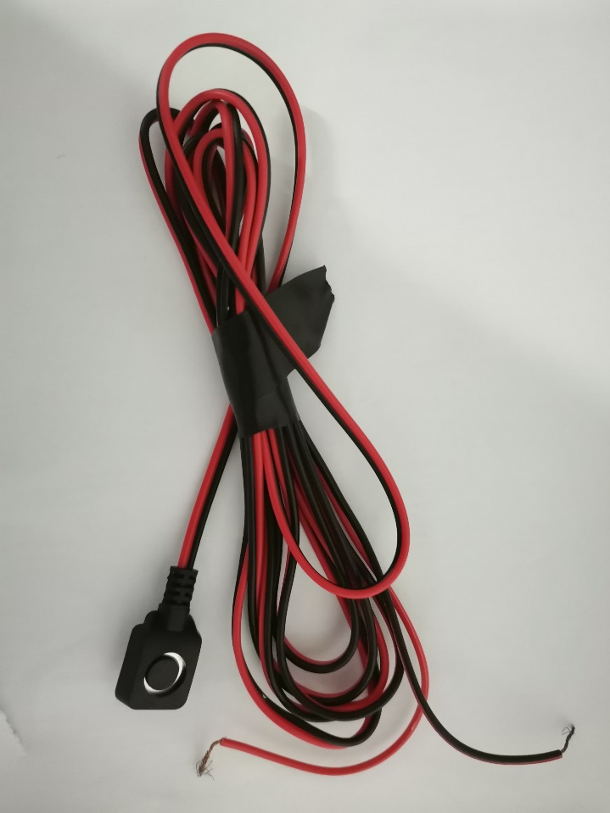

parameter
Item | Parameters
Environment temperature | -25℃～+70℃
Dielectric Strength | AC250V (50Hz for 1mi nute)
Rating | DC12V. 50mA
Electrically Life | 100. 000Cycles
Contact Resistance | ≤30m0
Travel | 0.2士0.05mn
Insulation Resistance | ≥100MO
Actuating Force | 100 -350gf
Relative Humidity | (40C)≤95%

size drawing
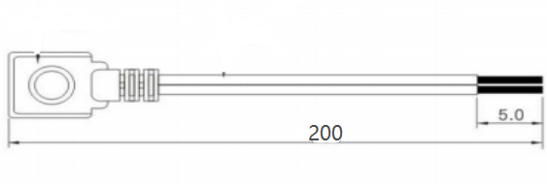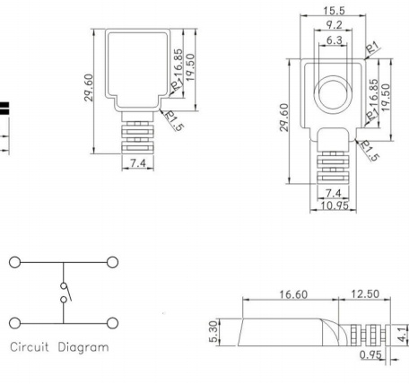
product component
Name | Model | Color | Materials | Quantity | Size
Injection moulding | Push-button alarm switch | black | PVC | 1
Switch | Reset switch | black | PA66 | 1
Follow-up material specifications | 2468 2pin | Black | PVC | 1 | 5ooMM

