MX-RLY-12-40 Relay
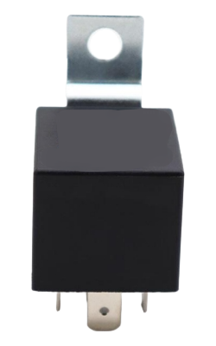
Product Introduction
Relays are electrical control devices used in vehicles . When the change in input quantity reaches the specified requirement, a relay causes a predetermined step change in the controlled quantity in the electrical output circuit. They are often used in automatic switching systems where small current controls large current operation . Relays play the role of automatic adjustment, safety protection, and circuit conversion in the circuit of the entire automotive equipment .

Features
- 40A contact switching capability
- Contact form 1Z: a set of rotary
- Assembled welding wire for easy use
- Relay pins comply with ISO 7588 PART 1

Core parameters
Electric shock parameters
Contact Material | silver oxide tin steel
Contact Forms | 1Z conversion
Contact Load | NO: 40A/14VDC
Contact Resistance | 50m 2
Max.Switching Current | 150A ON, 40A OFF
Electrical Life | 1*10⁵
Mechanical Life | 1*10⁶

Coil parameters
Nominal Volt  ( VDC ) | Coil Res.  X(1±10%)Ω | Shunt Res.  X(1±10%)Ω | Pull-in Volt.  ( VDC ) | Release Volt.  ( VDC ) | Max Applicable Volt.  ( VDC )
12V | 80 |  | 8 | 1.2 | 20.2(23 ℃)15.7(85℃)

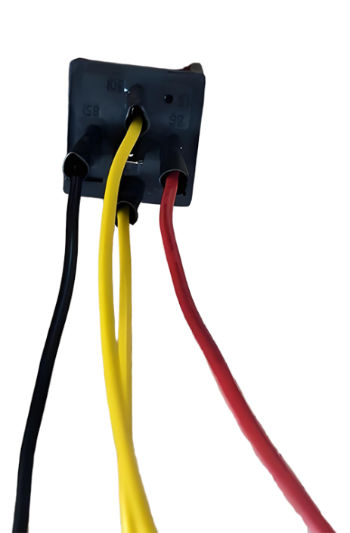
Harness parameters
86 Red Line
85 Black Line
30 87 Yellow Line
Wire gauge: UL1007 #18AWG
Cable length: 20cm
Thread tail: 10MM glue left
Heat shrink sleeve for welding

Product size
