77Ghz Millimeter Wave Radar Obstacle Avoidance Early Warning System
Manual
Table of Content

1. Product introduction
2. Product List
3. Technical parameters
4. Product function
5. Installation Instruction
6. Line connection legend

1. Product introduction
Thank you for choosing the 77Ghz millimeter-wave radar obstacle avoidance and early warning system produced by our company. The product consists of a main control box, (1-2) 77Ghz millimeter-wave medium and short-range obstacle avoidance radars, (1-2) indicator lights (or display + camera), a buzzer and connecting wiring harness.
Product application:
The 77Ghz millimeter-wave radar obstacle avoidance early warning system is suitable for installation around the body, and the area that needs to be warned corresponding to each position is set separately. It is widely used in heavy commercial vehicles such as trucks, construction machinery vehicles, and airport port machinery vehicles; and It can be used for automatic obstacle avoidance braking applications for docking electric scooter controllers, driving school car brake controllers and other equipment.
Main control box function:Receive and process 77Ghz obstacle avoidance radar data, and can be connected to 2 obstacle avoidance radars at the same time to set the radar warning range. The warning range is set in three areas within a rectangular range of 4 meters left and right with the radar as the center and 40 meters long. Level 3 early warning: Level 1 early warning (farthest): the prompt light is always on, and the buzzer does not sound; Level 2 early warning (middle distance): the prompt light flashes slowly, and the buzzer flashes off; Level 3 early warning (nearest): the prompt light flashes mob, and the buzzer sounds for a long time.
At the same time, it can output CAN data, TTL serial port data, and prompt light/buzzer signal.

Medium and short-range obstacle avoidance radar: The obstacle avoidance radar is a 77GHz vehicle-mounted millimeter-wave radar for detecting obstacles ahead when driving at medium and low speeds. Compared with infrared, laser and ultrasonic radars, this millimeter-wave radar is less affected by weather changes, has good anti-interference performance and range detection ability, and the detection distance can reach 40 meters.

Display screen (optional): The high-end stable solution of HiSilicon is adopted. The trigger line can receive the level signal output by the main control box and display it on the screen corresponding to the third-level warning. The first-level warning (farthest): flashing green box; the second-level warning (middle distance): flashing yellow box; the third-level warning (nearest): flashing red box. The camera can be connected to display the radar warning area screen accordingly.

2. Product List
Name | QTY
77Ghz millimeter wave obstacle avoidance radar | 1-2 (choose on demand)
Main control box | 1
Power cord | 1
Warning output line | 1
Buzzer | 1
Warning warning light | 1-2 (configured according to the number of radars)
Tip light extension cable | 1-2 pieces (4 meters/cable, configured according to the number of radars)
Radar line | 1-2 cables (5 meters/cable, configured according to the number of radars)
Radar mount | 1-2 (configured according to the number of radars)
Radar extension cable | 10 meters/cable (optional)
Display | 1 (optional)
Camera | (Optional/self-purchased)
Accessory bag | 1 pack
Manual | 1 book
- Main control box appearance diagram

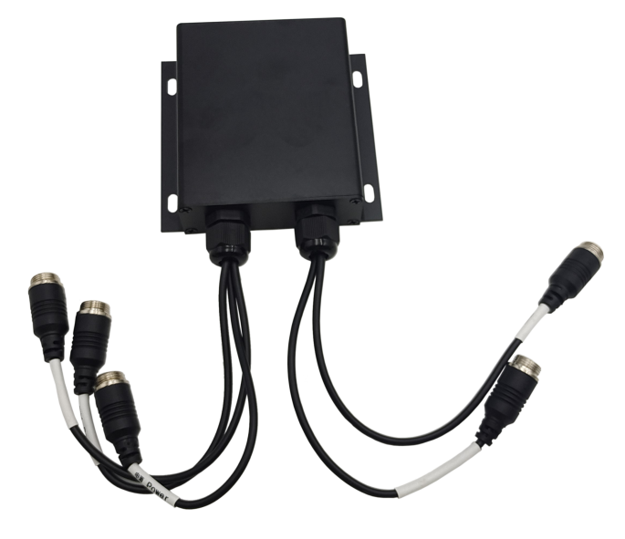

Shell size: 104 * 95 * 28mm

B. Radar appearance diagram
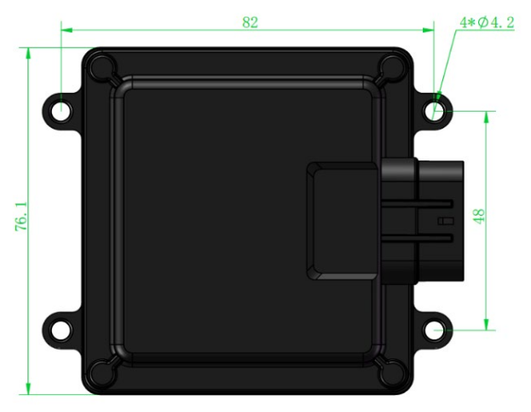
Radar size: 82 * 76.1 * 22.3mm
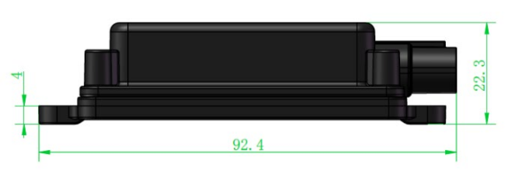
3. Technical parameters

No. | Item | Specifications
01 | Working voltage | 12-24V
02 | Radar operating frequency band | 77-78Ghz
03 | Operating temperature | - 40℃ ～ + 85℃
04 | Single radar power consumption | ＜2W
05 | Full load power consumption | ＜5W
06 | Seismic grade | 5.9G
07 | Waterproof protection | Ip67 (radar); IP65 (main control box)
08 | Refresh rate | 33Hz
09 | Number of transceiver channels | 2TX4RX
10 | Elevation Beam Width (6dB) | -2~8°
11 | Horizontal Beam Width (6dB) | －60°~＋60°
12 | Distance resolution | 0.2M
13 | Speed resolution | 1.9km/h
14 | Speed range | ±60km/h
15 | Detection distance | The length is 0.2~ 40m, the detection width can be limited, and up to 3 detection areas can be set (the distance of each area can be configured)
- Product function
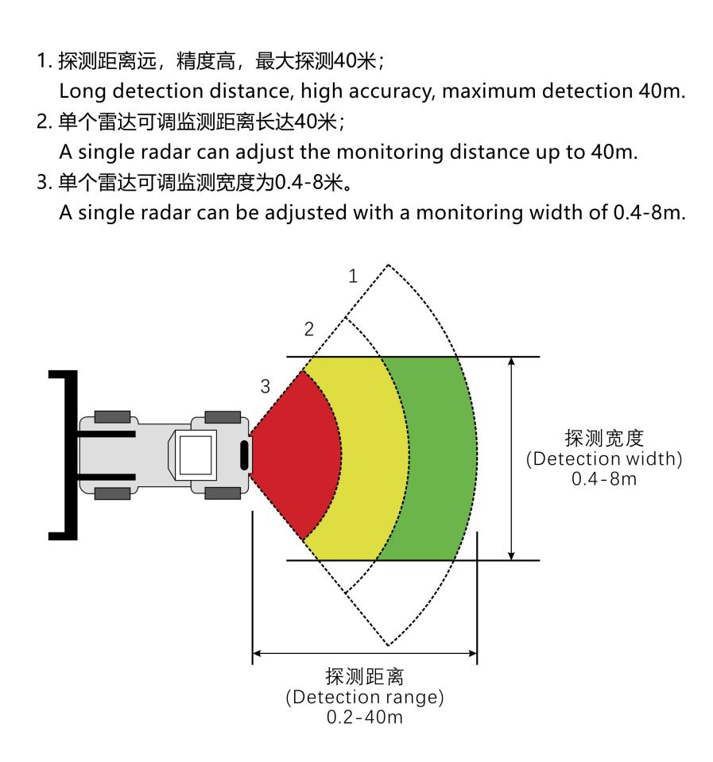
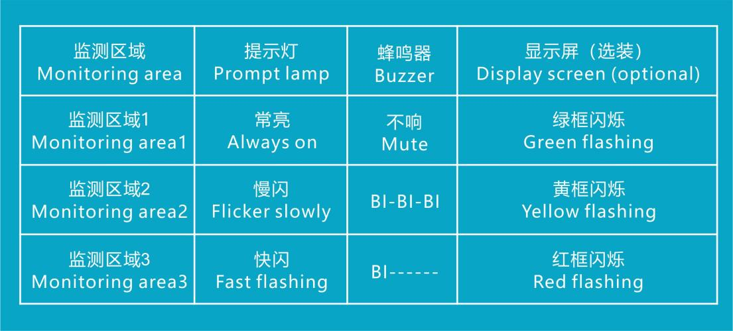

Installation Instructions
Please read the precautions carefully before installation! ！ ！
(1) Please keep the radar cover clean during installation. To clean the cover, wipe it with a soft damp cloth, and then air dry it naturally;
(2) When installing, please pay attention to the shape of the radar to ensure that the installed radar is not deformed, and do not squeeze, bump or hit;
(3) When installing, try to stay away from frequently started high-power electrical equipment and motors with strong magnetic field interference;
(4) During the test, there should be no obstruction within the radar beam range, and the testing environment should be as wide as possible to avoid affecting the measurement results.

Installation and Coordinate System
1) Installation direction: The antenna surface (flat surface) of the radar module faces the detection area, and is installed vertically and horizontally (due to the small pitch angle of the antenna, try to keep it perpendicular to the ground during installation); the connector goes out to the right;
2) Installation position: It is recommended to install at a height of 0.5~ 1m from the ground; if the installation height is less than 0.5m, the installation pitch angle needs to be adjusted appropriately;
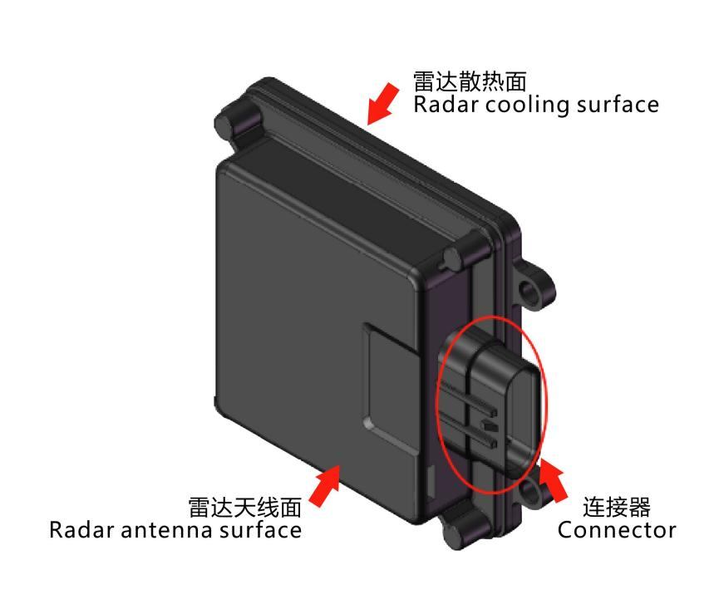
3) Coordinate system: as shown in the figure below:

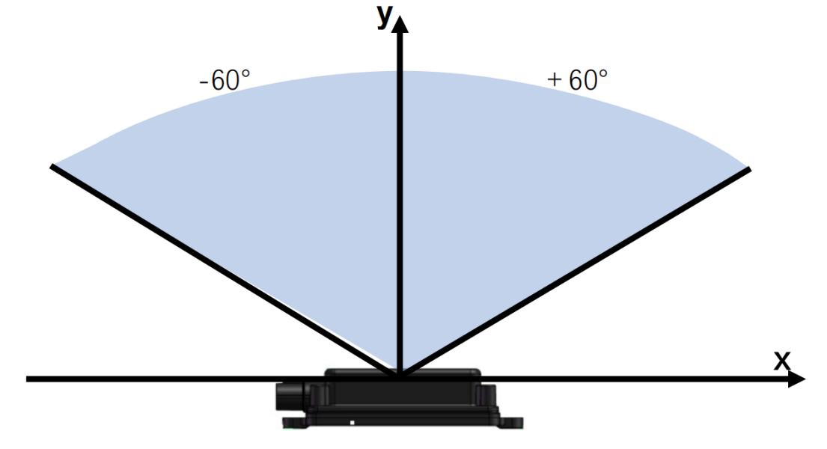

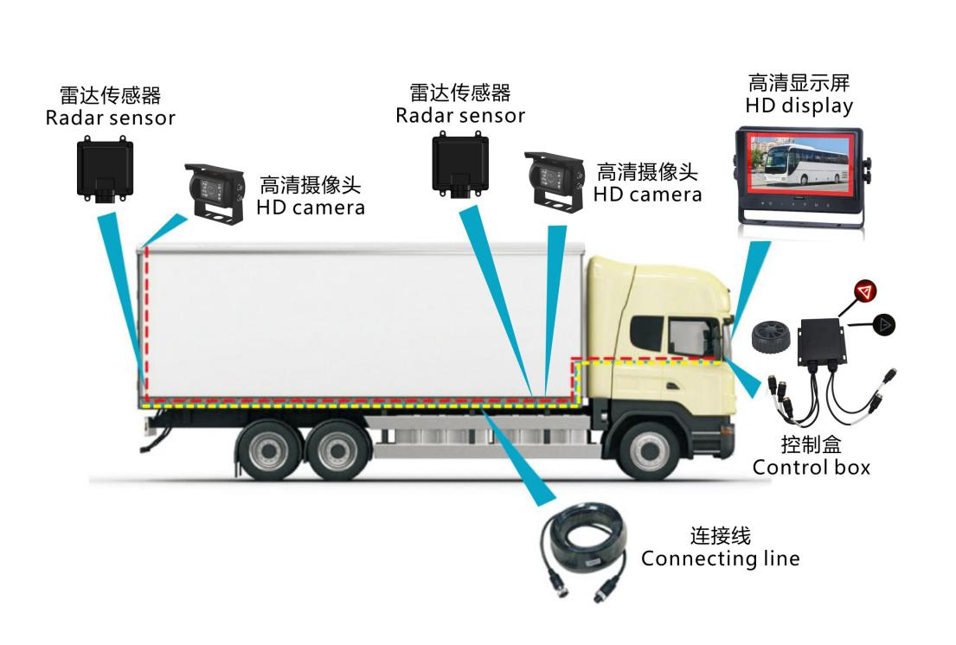
- Line connection legend

