Multifunctional expansion box
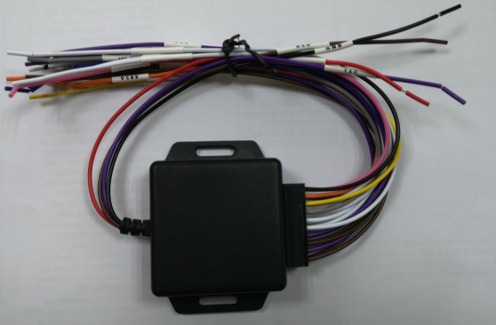

Functions＆features
- Support multiple serial port expansion, can dock more sensors, peripherals, expansion function is stronger.
- Support 4ch RS232 interface, each interface can be set up and work independently.
- Support 1ch RS485 interface.
- Support 4ch switch alarm input, 2ch analog alarm input, 1ch alarm output;
- Support 1ch PWM interface, input and output can be configured.

Technical Parameters
Project |  | Performance index
Input interface | power | 5V-12V
Input interface | GND | 1piece
Input interface | TXD(RS232) | 1 piece
Input interface | RXD(RS232) | 1 piece
Indicator light | power led | The indicator light comes on when the power is on，When there is data interaction, the lights flicker
Output interface | RS232 | 4 piece，independent work
Output interface | RS485 | 1 piece
Output interface | I/O Alarm input | 4 piece
Output interface | Analog quantity alarm input | 2 piece
Output interface | Alarm output | 1 piece
Output interface | PWM | 1 piece，configurable
Output interface | power output | 5V@1A

Installation matters
- Input interface definition
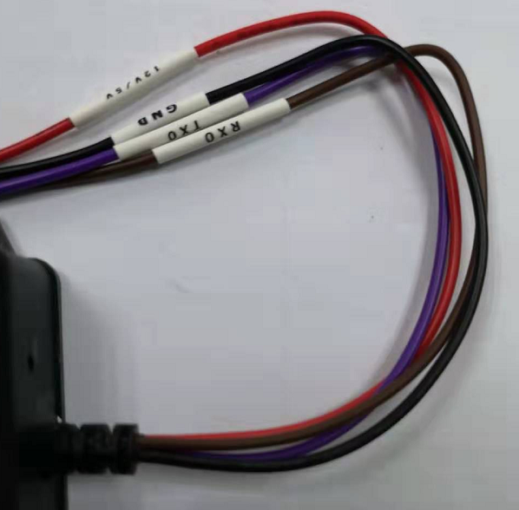
PIN | Color | Definition
1 | red | 12V/5V
2 | brown | RXD
3 | purple | TXD
4 | black | GND

- Output interface definition
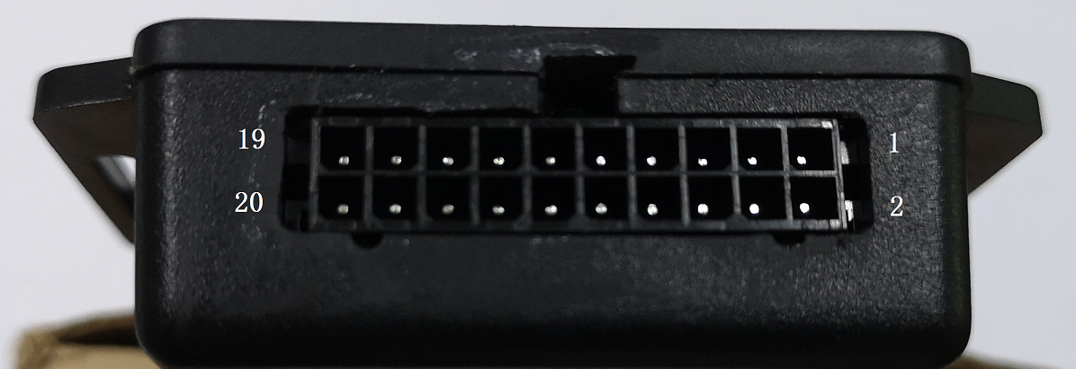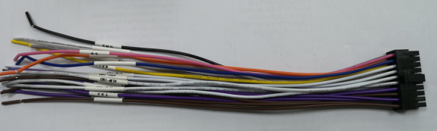
PIN | color | definition | PIN | color | definition
1 | brown | RX2 | 2 | brown | RX1
3 | purple | TX2 | 4 | purple | TX1
5 | brown | RX4 | 6 | brown | RX3
7 | purple | TX4 | 8 | purple | TX3
9 | white | ALM_IN2 | 10 | white | ALM_IN1
11 | white | ALM_IN4 | 12 | white | ALM_IN3
13 | gray | ALM_OUT | 14 | white | ADC_IN1
15 | yellow | 485B | 16 | white | ADC_IN2
17 | orange | 485A | 18 | blue | PWM
19 | black | GND | 20 | pink | 5V

