Multil- functional Mic
Model：MX-HMC-02
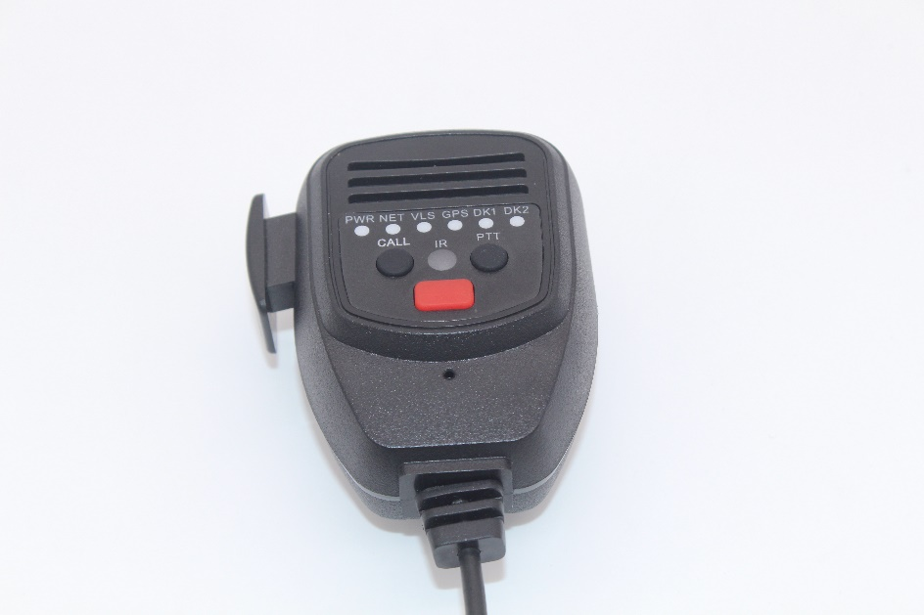

Product parameters
Item |  | Description
Video/Audio | Receiving sensitivity | 0.25μV
Video/Audio | Rated audio | 500mW
Video/Audio | Spurious suppression | 70dB
Video/Audio | Audio response | +1~-3dB
General | Working voltage | 5-12V
General | Water and dust resistant | IP54
General | Operating temperature | -30℃~+60℃
General | Size(H*W*D) | 82*58*40mm

Product size
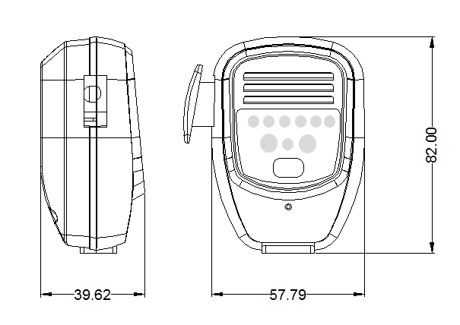
Installation matters
- Pins definition
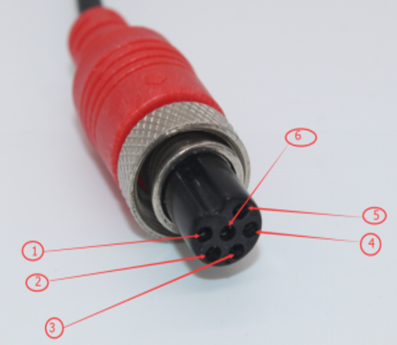
NO. | function | describe
1 | Power | 5-12V/200mA
2 | GND | GND
3 | RS232 RX | RX1
4 | RS232 TX | TX1
5 | MIC | IN
6 | SPK | OUT

