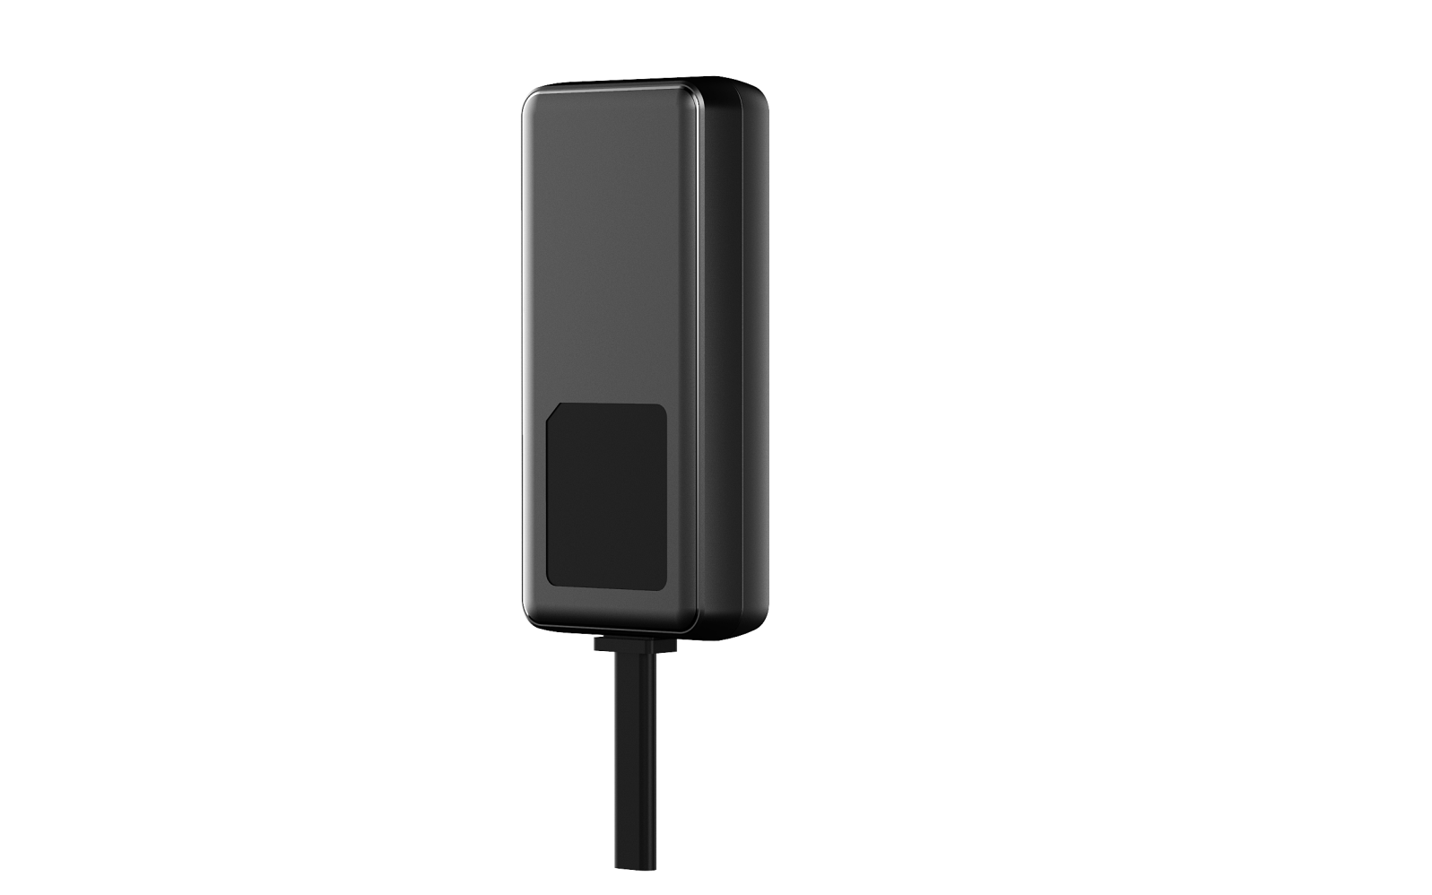

Product Parameters
GTRACKER-308 is a highly modular positioning product,Based on 4G communication network and GPS global satellite positioning system. Its Internet platform locates and monitors remote targets, and at the same time has functions such as ACC detection, mileage statistics, oil disconnection and power failure, and notifies the owner of the vehicle condition information through SMS and platform.This product supports various protocols such as JT808

Product advantages
- Intelligent positioning
- Remote control
- Motion alarm
- Fatigue driving
- Remote flameout
- Remote upgrade
- Trace play back
- Electronic fence
- Mileage statistics
- Power-off alarm
- Speed Alarm
- ACC detection

Parameters
Item | parameters
Name | 4G Mini GPS Tracker
Network | 4G/GSM/GPRS
Network band | FDD-LTE（B1/B3）/TDD-LTE(B38/B39/B40/B41)  850/900/1800/1900Mhz
Standby power standby | 180mA/4.2V(optional)
Power power independent working time | About 0.5 hours
Power waste | < 40mA/12V
Input power | DC 9V~100V/1.5A
Standby power standby | 180mA/4.2V(optional)
GSM/GPRS modules | CAT1
GPS sensitivity | -159dBm
GPS accuracy | 5-10 meters
Tracking sensitivity | -165dBm
The startup time for the first time | cold start time: 45-120s  warm start time: 35s  hot start time: 1s
Size | 75mm x 35mm x 15mm
Weight | 50g
Storage temperature | -40°C to +85°C
Operating temperature | -30°C to +75°C
Relative Humidity | 5%--95% non-condensing

