Fireproof Box Specification
Model：MX-FB-01-064

Function details
Vehicle fireproof box----waterproof and fireproof;
Video storage function;
Description
- Vehicle data protection box (waterproof and fireproof);
- It can further protect moving key data when a vehicle has a serious accident;
- The fireproof temperature is 550℃;
- It can withstand sea water, be sealed and float;
- Small size, light weight, bright color and easy to locate;
- Supports a SD card with maximum capacity of 64GB;
- Video storage function;
- Size (mm):156×99×76

Advantage
Vehicle data protection box is waterproof and fireproof;
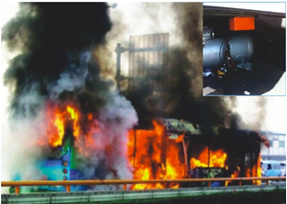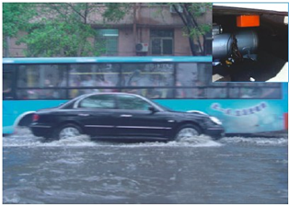
Working diagram
