Specification for Multi functional Alcohol Detector
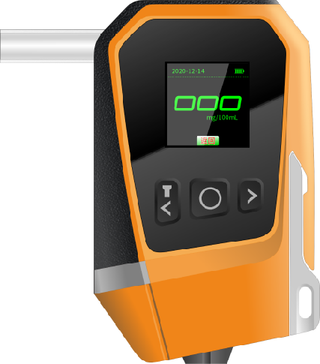
Product Introduction
The functional window breaking alcohol detector is a product specially developed for rapid alcohol detection and car window breaking. This product integrates multiple functions such as alcohol rapid detection, powerful window breaker, lighting, flashing light, cutting knife, strong magnetic suction cup, LCD display screen, etc. It has the characteristics of rapid and accurate detection, simple operation, and lightweight portability. The product supports optional customization of Bluetooth, car cables, etc.

Product Features
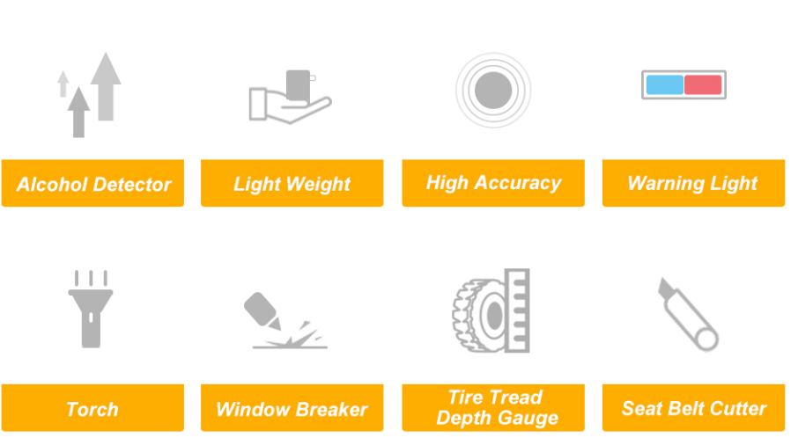

Core parameters
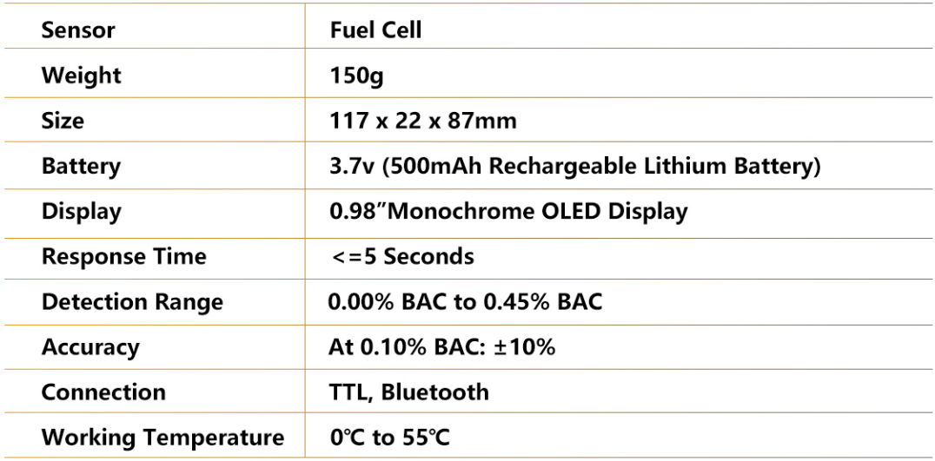

Usage
