AI Reminder Specifications
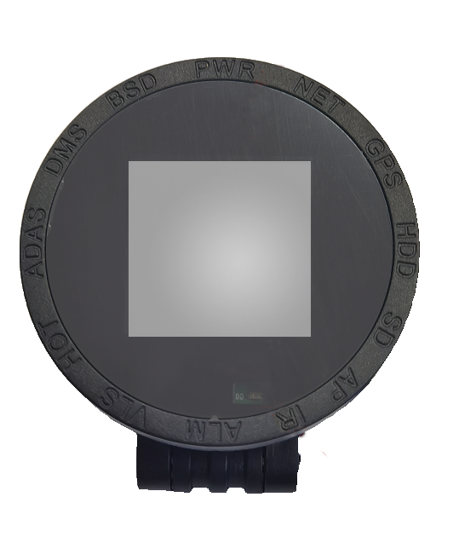

Product Introduction
The vehicle terminal is equipped with an AI-enabled voice and display device. When the device generates an alarm message, the alarm message is converted into an audio-visual reminder and an icon reminder , including "Do not drive distracted", "Do not drive fatigued", "Road deviation", etc., to attract the driver's attention and avoid traffic accidents. It is an ideal modern driving safety device.
Features
- Comes with icon reminder screen
- Comes with sound and light reminder
- Can take into account a variety of AI functions
- Loud sound and high clarity, suitable for noisy occasions
- Comes with docking wire and installation stickers , easy to install

Core parameters
project | Parameter Description
Operating voltage | Adapts to MDVR9~36V voltage and can be used in large, medium and small vehicles
Installation location | In-car only
Tail line length | About 2M ( the length of the sound and light reminder cable is 1.5M)
Tail line interface | Extended function tail line
Sound and light output | Left and right humanoid sound and light reminder
Audio version | Support English and Chinese versions

Please refer to the user manual for installation and tail line definition

