RS232-RS485
Model:MX-232T485-01-V1.0
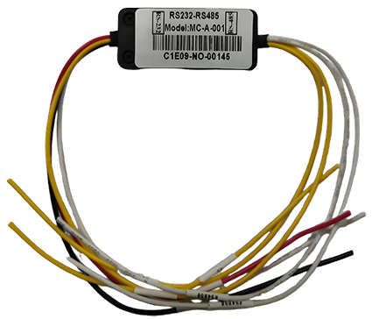
Core parameter
Item |  | Introduction
Power | power input，GND | 5~12V
Communication interface | RS232 | 1 set
Communication interface | RS485 | 1 set
Communication mode |  | Two-way communication
Size |  | 4.7(L)*2(W)*1(H) cm
Wire length | RS232 | 19.5 cm
Wire length | RS485 | 19.5 cm
Wire harness | power input | red，Casing text：12V/5V
Wire harness | GND | black，Casing text：GND
Wire harness | RS232 RX | white，Casing text：RX
Wire harness | RS232 TX | yellow，Casing text：TX
Wire harness | RS485A | yellow，Casing text：RS485A
Wire harness | RS485B | white，Casing text：RS485B

